***Budget Reports / Budget Entry***

**Table of Contents**

Bottom of Page Account Number Structure

Page 2 Budget Procedures

Page 2 State Allotment Funding – *alignment with Campus Improvement Plans*

Page 13 Budget Summary Report – *Current Year or Prior Year Report*

Page 17 Budget Entry – *Reviewing Detail Account Information Prior to Budget Entry*

Page 21 Budget Entry – *Chart of Accounts Option*

Page 25 Budget Entry – *Budget Process Option*

Page 29 Budget Summary Reports – *Compare Prior Year Budgets to Current Year Budget and Actual and New Data Entry of Budget*

Page 32 Budget Detail Report – *Detail descriptions and amounts for your Budget*

**Account Number Structure** – Example of an Account and what each section of the account number represents.

199-11-6299-19-001-0-11-900

199 Fund (General Operating Fund – GOF)

11 Function (Instruction)

6299 Object (Professional Services)

19 Sub-Object (Math)

001 Organization (High School)

0 Fiscal Year (used for Federal Funds only)

11 Program Intent (Basic Education)

900 Local Option Code (Technology begins with 9XX)

**Budget Procedures**

Each campus and department will submit a detail line item budget by account. The budget will be reviewed by central administration and administration’s recommendation will be taken to the School Board for approval. The School Board approves the budget by fund and function. Budget will be available for spending beginning September 1st of each fiscal year.

When developing your budget, it is best to review the prior year expenditures (see Budget Summary Reports below) and identify additional needs for the future year. The original budget from the previous year is rolled forward for you to use as a starting point. Each department should evaluate their individual budgets to determine if funds should be moved to a different account where there is a need for a budget. For example, if you plan to purchase additional technology supplies, you may want to move a portion of your budget from your regular supply budget to your technology supply budget.

All Campus/Department budget requests should be in the individual appropriate account number and include line item detail and be entered in whole dollar amounts. No cents in your line item detail.

New budget requests and increases to your overall campus or department budget need to be identified as “New” in the line item detail request.

***Campus budgets will need to be evaluated along with the Comprehensive Needs Assessment, Campus Improvement Plans (CIPs) and the District Improvement Plan (DIP) to ensure that the Budget request aligns with the Comprehensive Needs Assessment and Improvement Plans.***

Specific program intent codes (PICs) are related to the state allotment program funding and have specific spending requirements. These include 21 Gifted and Talented; 22 Career and Technical Education (CTE); 23, 33 Special Education (SpEd); 24, 26, 28, 29, 30, 34 State Compensatory Education (SCE); 25, 35 Bilingual and English as a Second Language (ESL) Education; 36 Early Childhood Education; 37 Dyslexia; 38 College, Career, and Military Readiness (CCMR); and 43 Dyslexia-Special Education. These specific program intent codes in the general fund (fund 199) and all federal funds (2XX funds) will need to align with the Comprehensive Needs Assessment and Campus Improvement Plans. To determine what funds are currently budgeted in each program intent code (PIC), you can run your budget reports below for each of these PIC codes by putting the PIC in the filter prior to running the Skyward report.

Local funds, funds that are in fund 199 and not associated with the state allotment program funds identified above, have more flexibility on spending, but all district funds must follow the district’s policies and procedures. ***PIC 99 is allocated for function codes 11, 12, 13, 21, 23, 31, 32, and 33 to the various State Allotment Programs. So if you are using PIC 99 in any of these function codes, you may not spend any of these funds on unallowable program costs throughout this document.***

Federal funds and the state allotment funds have more restrictive spending requirements. All state allotment funds should follow the district’s purchasing procedures and the additional guidance that is provided in the district’s State and Federal Grants Manual. Below is the guidance from the Texas Education Agency on allowable and unallowable program costs for each of the state allotment programs.

**Gifted & Talented (GT) 21**

**Allowable Program Costs**

* Textbooks and other instructional materials (which are guided by the State Plan for Education of Gifted and Talented students) beyond the basic educational program that are designed to meet the needs of students in the gifted and talented programs.
* Salaries for GT administrators that are **100% dedicated** to administrating and development of the GT program and services.
* **Stipends** for teachers providing GT services serving only GT students in the GT program **outside of their regular duties**.
* Salaries for **“GT Specialist”** that serve **only** GT students in the GT Program.
* Teachers may be split funded and paid salaries from the GT supplemental state allotment program for time the teacher serves **only** **GT students** in the GT program.
* Teachers serving a mix of GT students and regular education students during a class period, as a part of their regular duties **may only** be paid salaries for time teaching **Advanced Placement (AP) courses designated as part of the high school GT program**.
* Professional development costs for GT administrators and teachers (which are guided by the state plan).
* Advanced placement courses designated as part of the GT program.
* Gifted and Talented Services for students.
* Funds may be used for MATHCOUNTS, Future Problem Solving, Odyssey of the Mind, and Academic Decathlon, as long as these funds are used to train personnel and provide GT program services.

**Unallowable Program Costs**

* Teachers serving a mix of GT students and regular education students during a class period, as a part of their regular duties **may not** be paid salaries, **unless** it is for time teaching Advanced Placement (AP) courses designated as part of the high school GT program.
* Costs for Teacher Certifications

**Career and Technical Education (CTE) 22**

**Allowable Program Costs**

* Expenses have been expanded beyond high school to the 7th and 8th grade in 2019-20 as long as it is an allowable program cost.
* Expenses related to initiating, improving, expanding, and modernizing CTE equipment, supplies, or materials. CTE equipment must be **industry specific** not general equipment that may be used in a general classroom.
* Expenses related to improving or developing **new** CTE courses.
* Expenses related to developing, improving, or expanding **the *use*** *of technology* in CTE courses.
* Expenses related to performance or recruitment incentives **established** in local policy and employment contracts.
* Salaries, benefits, stipends, extra-duty pay for CTE teachers, CTE paraprofessionals, and CTE administrators.
* Expenses for construction, renovation, or remodeling of **existing** CTE facilities.
* Expenses for lease, purchase, upgrade, or **adapt** **items** designed to strengthen and support academic and technical skill achievement.
* Expenses for CTE instructional aids and publications (including digital or electronic publications).
* CTE instructional aids and publications purchased with state supplemental CTE funds ***must be supplemental and ancillary* in nature** to the CTE program.
* CTE instructional aids or publications are defined as industry trade magazines, and publications produced by industry professional organizations that provide:
  + CTE students with the latest news affecting the industry, current trends, issues or upcoming events such as training conferences, exhibits, competition events, etc.
  + CTE students with practical advice from professional leaders and/or companies in the industry that promote or introduce common or new industry tools, and useful products for use or sale in a particular profession.
* Expenses for motorized vehicles and trailers used exclusively for the benefit of CTE students in the CTE program.
* Expenses related to consumable supplies (useful life is less than one year) used exclusively for the benefit of CTE students in the CTE program such as office supplies, paper, computer supplies, building and maintenance supplies, or laboratory supplies.
* Expenses for culinary food costs related to the CTE program.
* Expenses for materials and resources related to advisory council meetings; career fairs; CTE student and parent activities, or business industry stakeholder meetings.
* Expenses for distance learning courses for CTE personnel such as teachers, administrators, and counselors.
* Expense for preparation and / or earning an industry-based certification *(Excluding TEA reimbursement – see unallowable costs below.) This may also be paid under CCMR (district may choose where to charge this expense)*
* Expenses for CTE student services such as field trips to colleges, career fairs, and college, career or academic guidance and counseling.

**Unallowable Program Costs**

* Expenses for construction, renovation, or remodeling of **new** CTE facilities. Expenses to renovate an existing facility from a regular education facility to a CTE facility.
* Core curriculum (instructional aids) that is ***not supplemental and ancillary* in nature.**
* Expenses for the purchase of materials in which the **materials will be used to create something that will be put up for sale**.
  + *The Director of Accounting should be notified prior to selling any item that was purchased with CTE funds.*
  + If sold, the revenue must be booked back to the expense account and would reduce the state allotment expenses for the CTE program.
  + No item may be gifted to employees, school board, etc.
  + Example if food is prepared, it may be shared with students as long as it does not interfere with the National School Lunch program.
* Industry-Based Certifications that will be reimbursed to the district by TEA if submitted in the PEIMS summer submission. Only one reimbursement per student throughout Grade 9-12 will be allowed for reimbursement by TEA. *(Certifications may be expended to PIC 22 if no TEA reimbursement is requested.)*
  + Reimbursable expenses will be coded in Function 11, PIC 11, and Local Code R22.

**Special Education (SpEd) 23, 33**

**Allowable Program Costs**

* Expenses for personnel assigned to instructional or other duties in the special education program and/or to provide support services to the regular education program in order for students with disabilities to be included in the regular program.
* Expenses for support services that include, but not limited to, collaborative planning, co-teaching, small group instruction with special and regular education students, direct instruction to special education students, or other support services determined necessary by the Admission, Review, and Dismissal (ARD) committee for an appropriate program for the student with disabilities. Assignments may include duties supportive to school operations equivalent to those assigned to regular education personnel.
* If personnel are assigned to special education on less than a full-time basis, except as stated in 19 TAC §89.1125(a), only that portion of time for which the personnel are assigned to students with disabilities will be paid from state special education funds.
* Expenses for special materials, supplies, and equipment which are directly related to the development and implementation of IEPs of students and which are not ordinarily purchased for the regular classroom. **NOTE: Office and routine classroom supplies are unallowable costs to the SPED program.**
* Expenses for special equipment may include instructional and assistive technology devices, audiovisual equipment, computers for instruction or assessment purposes, and assessment equipment only if used directly with students.
* Funds may be used to contract with consultants to provide staff development, program planning and evaluation, instructional services, assessments, and related services to students with disabilities.
* Funds may be used for transportation only to and from residential placements. Prior to using federal funds for transportation costs to and from a residential facility, a district must use state or local funds based on **actual expenses** up to the state transportation maximum for private transportation contracts.
* Funds may be used to pay staff travel to perform services directly related to the education of eligible students with disabilities.
* Funds may also be used to pay for the joint training of parents and special education, related services, and general education personnel.
* Funds may also be used to pay travel of staff (including administrators, general education teachers, and special education teachers and service providers) to attend staff development meetings for the purpose of improving performance in assigned positions directly related to the education of eligible students with disabilities.

*Examples of allowable educational materials and assistive technologies for students with disabilities*

* E-Readers
* Brailers
* Speech recognition software
* Online caption software
* Assistive listening Devices
* Magnification software
* Closed circuit televisions (CCT)
* Alternative keyboards
* Audio books and publications
* Page turners, pencil grips
* Electronic math worksheets
* Data manager software
* Optical character recognition software
* Portable word processing devices
* Screen readers
* Talking calculators
* Word prediction software programs
* Variable speed tape recorders
* Independent riding devices
* Canes
* Various switches to activate devices
* Communication boards and devices
* Cause and effect toys
* Helmets
* Communication boards/low tech
* Classroom calendars & weather tangibles
* Games to develop social skills
* Life skills vocations tasks items
* Developmental curriculum
* Sorting materials
* Community signs
* Floor mats
* Sensory materials
* Weighted vests and blankets
* High interest reading materials
* Basic musical instruments
* Text-to-speech software
* Abbreviation expander software
* Proofreading software programs
* Adaptive mouse keys
* Supplementary reading materials
* Planned reward activities and items
* Portable class/desk dividers
* Individual organization binders/baskets
* Arts and craft materials
* Behavior intervention curriculum
* Reinforcement disposables
* Tangible behavior cues
* Standing boards
* Exercise balls
* Folding parallel bars
* Special swing seats
* Floor sitting systems
* Wedges and mats
* Balance boards
* Life skills classroom bigger ticket items, i.e. stoves, refrigerators, etc.
* Social skills curriculum

**Unallowable Program Costs**

* Office and routine classroom supplies.
* In no event shall the purpose for attending staff development meetings include time spent in performing functions relating to the operation of professional organizations.
* *Video Surveillance of Certain Special Education Settings - T*exas Administrative Code(TAC) §103.1301(d), states, ”A district or charter school is not permitted to use Individuals with Disabilities Education Act, Part B, funds **or** state special education funds to implement the requirements of Texas Education Code (TEC) §29.022. *(Correct coding: Function 52, PIC 99, LOC 023 or 923)*

**State Compensatory Education (SCE) 24, 26, 28, 29, 30, 34**

**Allowable Program Costs**

* **Supplemental** cost for equipment and other supplies required for quality instruction.
* **Supplemental** staff expenses to reduce class size or provide individualized instruction for at risk students.
  + Time and effort **must** be on file for SCE **positions that are not 100%** SCE funded.
* **Supplemental** stipends, and extra-duty pay.
* Alternative Education Program expenses as supported by the approved CIP/DIP.
* SCE costs **must** **supplement** the costs of the regular education program and must be used for costs of program and/or services that are **supplemental** to the regular education program **and** are designed for student at risk of dropping out of school. Additionally, the students who are designated as educationally disadvantaged can receive supplemental services.
* **All services provided must be** written in the Board approved District/Campus Improvement Plans.
* TEC 42 provides some flexibility that allows districts to coordinate funding so that SCE can support schoolwide campuses to be more effective. However, SCE funds must still be treated as **supplemental** funding for all Title 1, Part A programs on schoolwide campuses in accordance with the Texas Education Code (TEC), §42.152(c).

**Unallowable Program Costs**

* Per TEA, districts are prohibited from using Foundation School Program (FSP) compensatory education allocations for students at risk of dropping out of school to supplant resource allocations for the regular education program.
* The term ‘regular education program’ or foundation curriculum applies to basic instructional services that all eligible students are entitled.
* On a Title I campus, SCE funds **may be used to support** the federal program, but again, **may not be used to meet** federal requirements, and also must **support the purpose** of SCE which is to supplement the basic program with compensatory accelerated instruction in order to reduce any disparity in **performance on assessment instruments** administered under Subchapter B, Chapter 39., TEC, or reduce disparity in the **rates of high school** completion between students at risk of dropping out of school and all other LEA students.
* Dyslexia screening and **services that are required under Texas Education Code, Section 38 may not be** funded with SCE; therefore, SCE cannot fully fund the LEAs dyslexia program.
* SCE must supplement the regular education program for qualifying students (students who meet at risk criteria).
* All students served with SCE – including those with dyslexia – **must meet** at least **one** **statutory criteria** (of the 13 eligibility criteria in statute) or local eligibility criteria before being coded at risk of dropping out of school.
* SCE **may not** be used to pay for staff that fulfill other state or federal mandates.
* SCE funds **may not** be used to pay salaries for special education teachers.
* Local criteria may be approved by the local board of trustees, and some districts do use dyslexia as a local criteria. However, **services still must be supplemental to the basic program for dyslexia services offered by the district/campus***. (Lampasas ISD currently does not have Board approved local criteria.)*
* The total number of students receiving SCE services under local criteria per school year **may not exceed ten percent** **of the number of students** who met one or more statutory criteria and were served in the SCE program in the preceding school year.

**Bilingual Education Allotment 25, 35**

**Allowable Program Costs**

* Classroom instructional materials that are state aligned to Texas Education Knowledge and Skills (TEKS) to support emergent bilingual students including immigrant students.

Examples of Classroom Instructional Materials:

* Bilingual thesauruses and dictionaries.
* Bilingual/ESL classroom equipment such as label maker machines and/or laminating machines for classroom instruction.
* High Interest books and posters.
* Magnets for word walls.
* Salaries for bilingual and ESL teacher aides/paraprofessionals**.**
* Recruitment or Job Fair costs targeting bilingual teachers. (Recruitment materials **must** demonstrate how Bilingual Teachers were the target of the recruitment activity.)
* Salary supplements for certified bilingual and ESL teachers such as Stipends, and one time hiring bonuses, extra duty pay that are approved in employment contracts and local policy.
* Professional development targeting competencies needed to serve the needs of ESL students.
  + Districts that apply for a Bilingual Education Exception and/or ESL Waiver must assure that they will use a minimum 10% of total Bilingual Education Allotment funds for staff development.
  + The 10% is applied to the 55% of Bilingual Education Allotment direct program costs.
* Travel costs for state conferences related to Bilingual and ESL programs.
* Reimbursement for the cost of Bilingual or ESL certification test for teachers that **passed** the certification test.
* Enhancement of Parent Resource Centers for English Language Learners (ELL) parent and student involvement activities.
* Classroom technology enhancements for teachers and students.

Brief Examples of Technology Enhancements:

* Smart boards
* Bilingual Language Software

**Unallowable Program Costs**

* Salaries for Bilingual and ESL certified teachers.
* Salaries for Bilingual and ESL Administrators or Coordinators.
* Salaries for Intervention Specialists.
* Interpreter services, salaries or contracted.
* Travel expenses for national conferences.

**Early Childhood Education 36**

**Allowable Program Costs**

* Fund programs and services designed to **improve student performance in reading and mathematics in prekindergarten through third grade**, including programs and services designed to assist the district in achieving the goals set in the district’s early childhood literacy and mathematics proficiency plans.
* Stipends for kindergarten through third grade teacher attendance at **reading academies**.
* **Phonics curriculum** that uses systematic direct instruction in kindergarten through third grade to ensure all students obtain necessary early literacy skills.
* Integrated **reading instruments** used to diagnose reading development and comprehension to support each student in prekindergarten through third grade.
* Funds are allocated to improve student performance in early elementary reading and mathematics, which include supporting a full-day prekindergarten.
  + Fund the second half of the day for full-day prekindergarten for eligible four-year-olds.
  + Purchase classroom supplies, desks, chairs, books, etc. for the expansion of prekindergarten classrooms.

**Unallowable Program Costs**

* Districts will receive FSP funding for the **first half of the day of pre-kindergarten**, so it is not an allowable program cost.
* **Reading academies** for anyone that is not teaching kindergarten through 3rd grade or an elementary campus principal.
* Expenses related to **reading academy trainers.**

**Dyslexia or Related Disorders 37**

**Allowable Program Costs**

* Costs incurred to screen for, evaluate, or identify dyslexia or a related disorder.
* Services for regular education aids and services (instructional accommodations) provided under a 504 accommodation plan for each student that the district serves who has been identified as having dyslexia or a related disorder.
  + Tools and instruments used to screen, progress monitor, and/or evaluate for dyslexia and related disorders.
  + Training in the identification of dyslexia for evaluation personnel.
  + Professional development in science of teaching reading.
  + Regular education aids and services, such as instructional accommodations, provided to a student who has been identified as having dyslexia or a related disorder under a 504 accommodation plan.
  + Personnel costs for the screening, evaluation, and identification of students with dyslexia.

**Unallowable Program Costs**

* Services provided to a student who has been identified as having dyslexia or a related disorder and who receives special education services should be coded to PIC 43.

**College, Career, & Military Readiness (CCMR) 38**

**Allowable Program Costs**

* **Support for College and Career Advising**
  + Preparation, professional development, and **training for counselors** on:
    - FAFSA
    - College entrance requirements
    - Career awareness and exploration activities for students
    - Work-Based Learning
* **Support for establishing and/or maintaining College and Career Readiness School Models**
* **Support for Teacher and Student Preparation**
  + Preparation, professional development and **training for teachers** on:
    - * Advance Placement (AP), International Baccalaureate (IB), Dual Credit, ACT, SAT, TSIA, early college school models, CTE, AVID, ASVAB, NJROTC, WBL.
  + Preparation for **students** may include:
    - Assessment study guides
    - College preparation assessments and pre-assessments such as SAT, ACT, PSAT, PSAT 8/9, ACT Aspire, TSIA, etc. *(not being reimbursed – see unallowable program costs)*
    - College credit earning opportunity, including AP, IB, CLEP, and Dual Credit courses.
    - ASVAB preparation
    - Salary for extended tutoring
    - Salary for assessment preparation course
* **Counseling and Advising Services**
  + Activities to help students identify which courses prepare them for a specific career or college degree plan.
  + Activities to provide awareness and support for students who wish to enlist in the military.
  + Sessions with content for FAFSA, college entrance requirements, career awareness and exploration activities, work-based learning opportunities, and developing a college degree plan.
  + Outreach sessions for students and parents with CCMR content, including participation in courses with college credit earning potential (including AP, IB, and Dual Credit) and earning CTE Industry-Based Certifications.
* **Work-based learning (WBL) opportunities**
  + Videos and training for externships and internships
  + Lessons to gain employability skills
  + Transportation to work sites
  + Intermediator contracts for services to facilitate/monitor students and work experience
* **CTE and Industry-Based Certification(IBC) activities**
  + Student and parent awareness sessions
  + Pre-certification assessment activities
  + Travel to test center for IBC
* **College and Career Readiness School Models (CCRSM)**
  + Exploration activities and pre-planning year expenses
  + Establishing an advisory team
  + Operating expenses, including facility/utilities, salary, tuition, and textbooks
  + Negotiating college and business partnerships
  + Community outreach to encourage enrollment
  + CCRSM Conference travel
* Technology tools/platforms that assist in advising students in college and career readiness
* Expenses include equipment, supplies, salaries, stipends, tutors, software/subscriptions, rental, transportation, or any expense incurred to prepare students for an opportunity to meet the measures tied to CCMR.

**Unallowable Program Costs**

* Student scholarships to postsecondary
* SAT / ACT basic exam that will be reimbursed to the district by TEA if administered as a “School Day Administration” at the high school or a non-school day administration that is requested as a reimbursement. Only one test per student in spring of junior year or during the senior year will be allowed for reimbursement by TEA. *(Exam fees may be expended to PIC 38 if no TEA reimbursement is requested.)*
  + Reimbursable expenses will be coded in Function 31, PIC 99, and Local Code R38.

**Dyslexia - Special Education 43**

**Allowable Program Costs**

* Services for students with dyslexia or a related disorder and who has an Individualized Education Plan (IEP) that specifically states that dyslexia services are required.
  + Dyslexia instruction by a person with specific training in providing that instruction.
  + Personnel costs for licensed, trained, or certified providers of dyslexia instruction.
  + Evidence-based dyslexia program materials.

**Unallowable Program Costs**

* Regular education aids and services (such as instructional accommodations) provided under a Section 504 accommodation plan to a student who has been identified as having dyslexia or a related disorder should be coded to PIC 37,
* Screening for, or evaluation and identification of dyslexia or a related disorder should be coded to PIC 37.
* The district will continue to use PIC 24 for supplemental dyslexia expenses including supplemental programs and services for students who have dyslexia or a related disorder.

**Budget Summary Reports – Current Year or Prior Year Report**

Before you begin to enter your budget for the new fiscal year. You are strongly encouraged to review your current year budget information. You can review a report of your accounts by following these procedures. Log into Skyward Finance (Web).

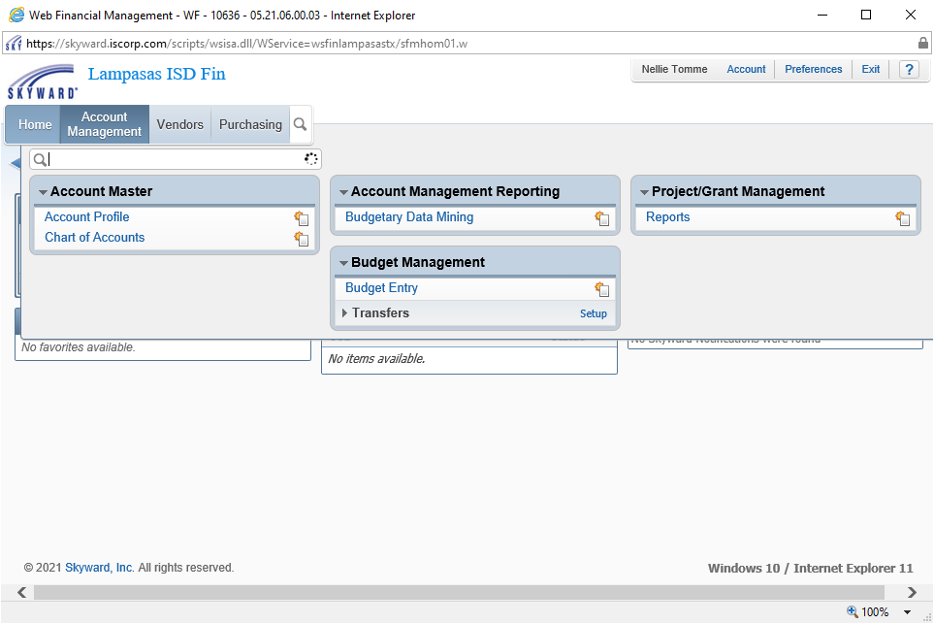

Select the following path under Budgetary Data Mining: **Views** (drop down menu) select: Revenue and Expense Reports - Summary. Under **Filters** (drop down menu) select: All Users’ Reports. Then Click on the “**Created By**” title and the system will sort and put all reports created by BUNTIWAN000 toward the top of the list. Once you have the screen below, select the Campus/Dept Budget Report that pertains to your Campus / Department and click **Print**.

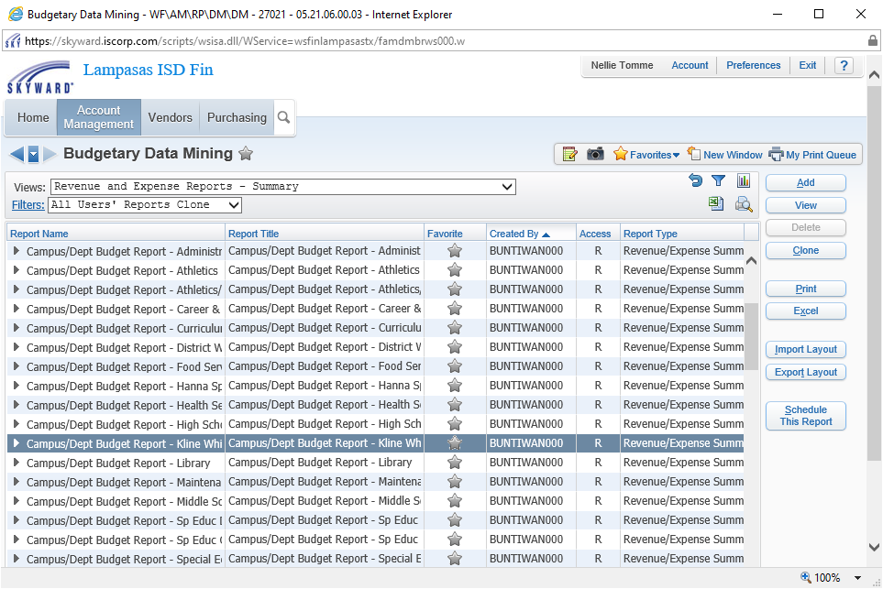

Select the reporting Month, you can use the **current month** and information on the report will be for the current fiscal year through the current month selected. If you want prior year information, you can select August from a prior year and the fiscal year information for a prior year will be on the report. For a 2020-21 fiscal year report, you will select August 2021.

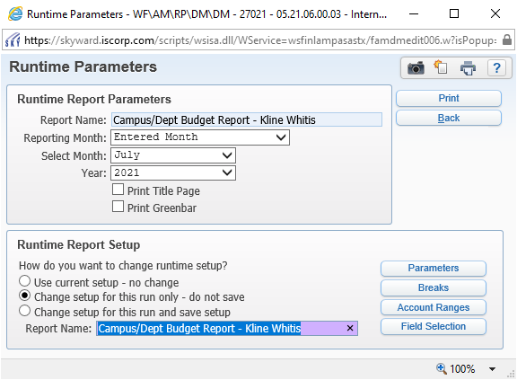

If you run the report using the “Use current setup – no change option”, this will run your entire budget (including salary budget). If you select the “**Change setup for this run only – do not save option**”, then you can update the **Account Ranges**.

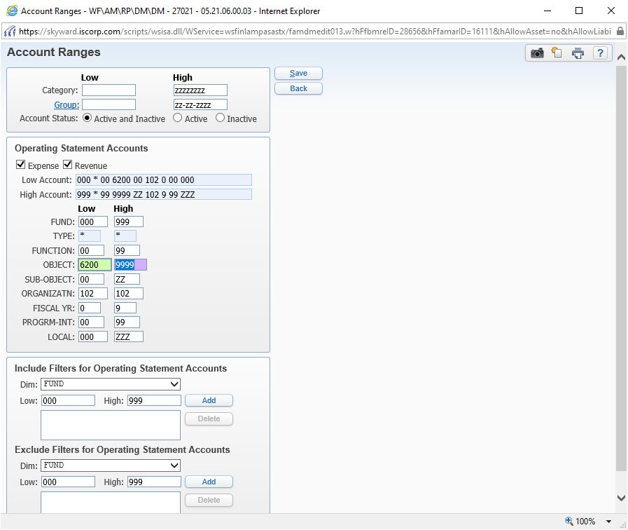

Under Operating Statement Accounts update the **Low number for Object to 6200** click **Save**. This will run all non-salary accounts for your campus / department.

After saving you will go back to this screen and you will click **Print**.

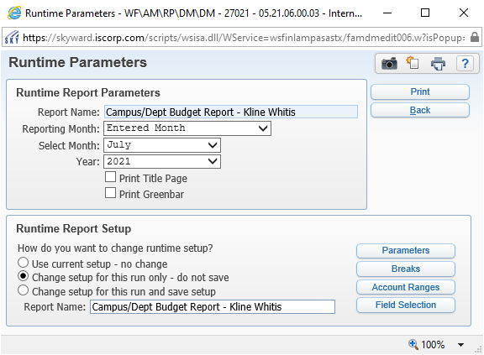

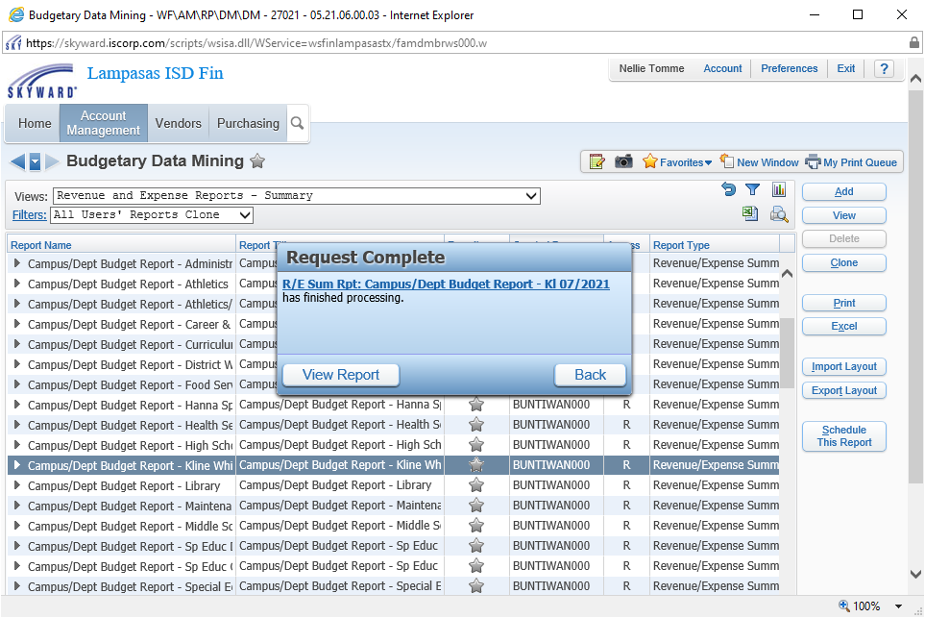

Click **View Report** (above). The report will be displayed. If you move your mouse to the bottom center of the report the save and print options will appear. Below is the report that will run, you can save the report to your computer or you can print the report. The report will show the revised budget which includes all processed budget transfers and budget amendments, your current month activity, fiscal year to date activity, encumbrances (Outstanding Purchase Orders), and your Unencumbered or Remaining Balance.

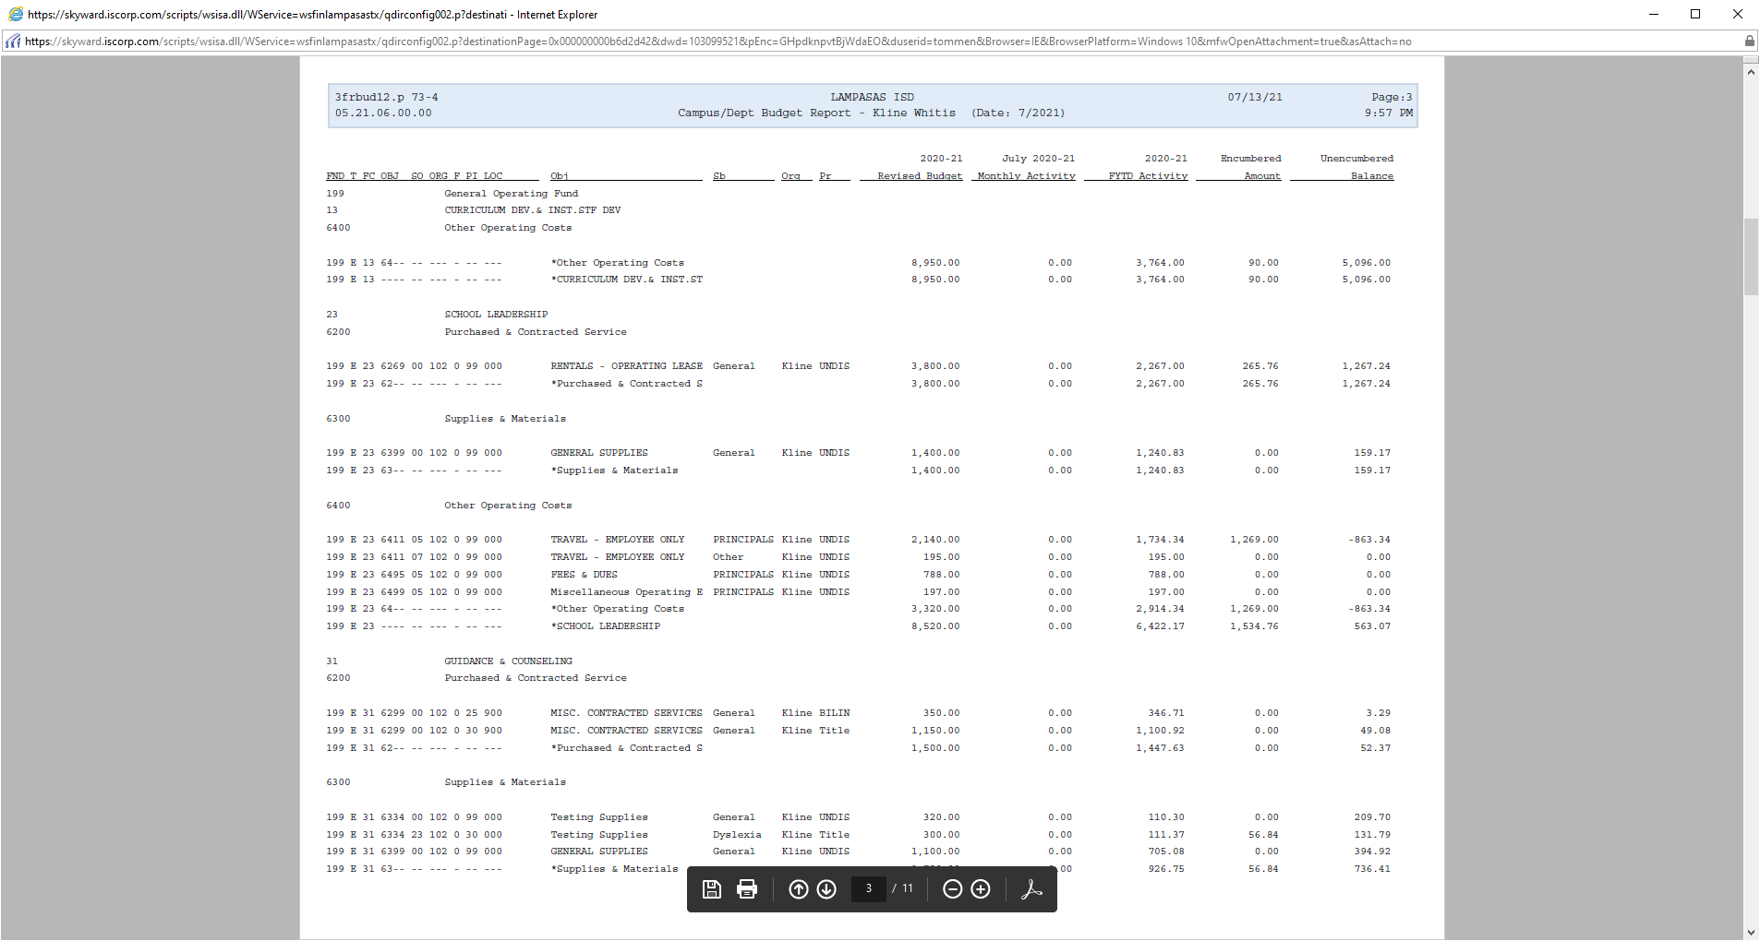

You can select print above and then select the printer that you wish to print the file to or save the file on your computer as a PDF. Once you choose the printer name or Adobe PDF, click on print.

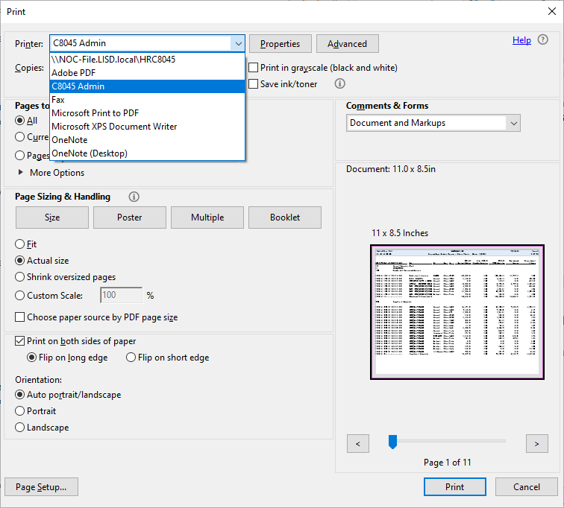

When you review your current budget and need to transfer funds to clean up negative balances throughout the year, refer to the Budget Transfer Procedures for more information.

**Budget Entry for All Non-Salary Accounts (62XX to 66XX)**

*Salary accounts (61XX) will be updated by the Administration office. If you would like to provide assistance to any of your salary accounts (tutorials, extra duty, etc.), please contact the Director of Accounting so that budgets may be adjusted per your request.*

Select the following path: Financial Management > Chart of Accounts.

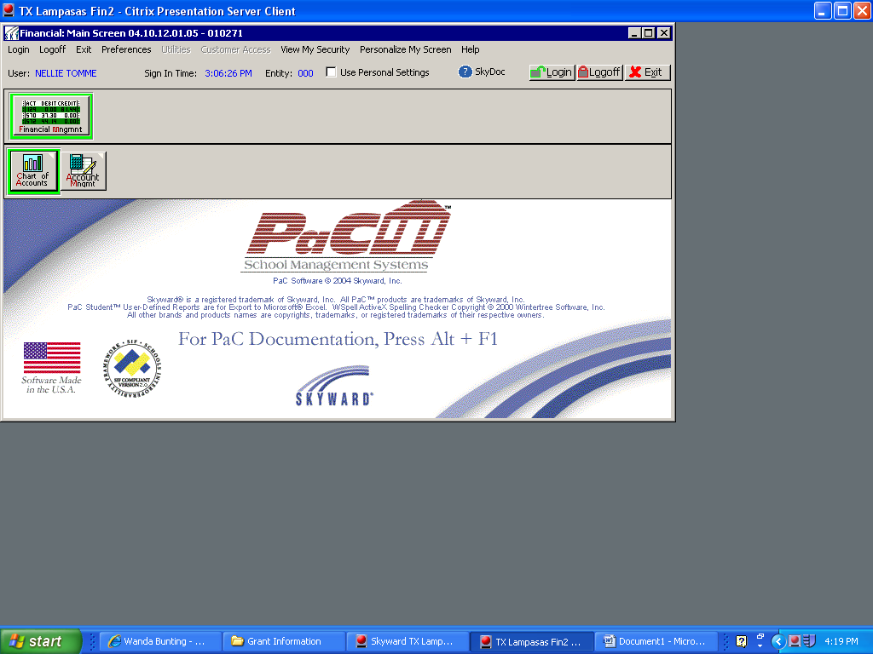

Enter an account that you would like to start with, account entered below is 199-11-6299-00-001-0-11-000 and click OK.

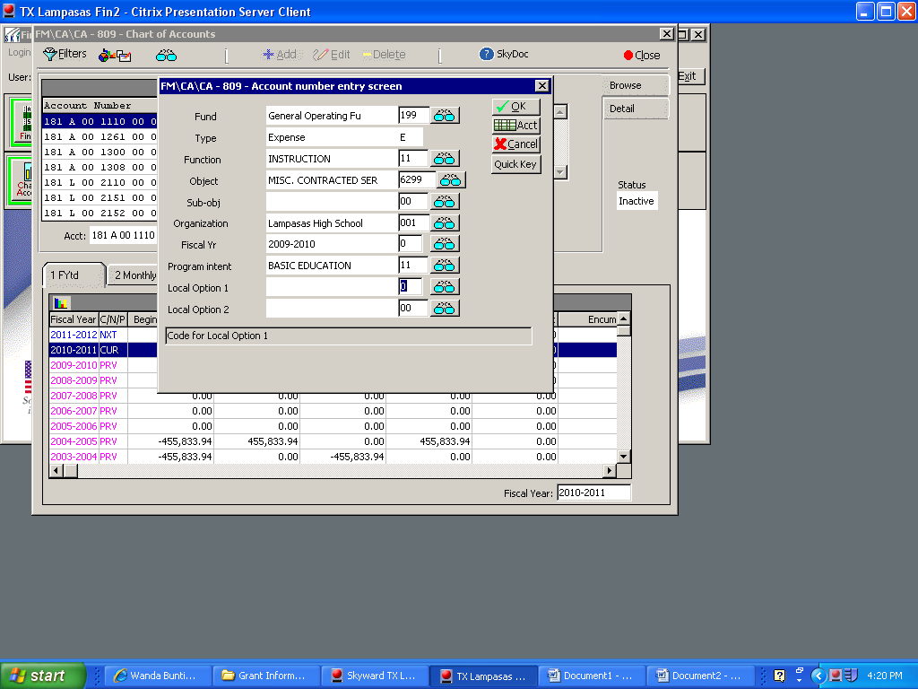

If you enter an account that does not exist, the account number selection screen will appear for you to select an account from the list. Click on the account number and the Select button.

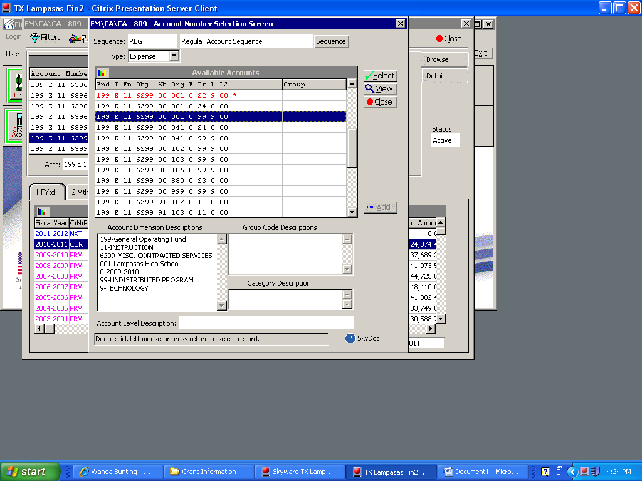

The account will display below. The FYtd is the summary information by fiscal year for the account. To see the detail you will click on the Act tab and detail activity for the current year will display. To update the budget, you will click on the Bud’s tab.

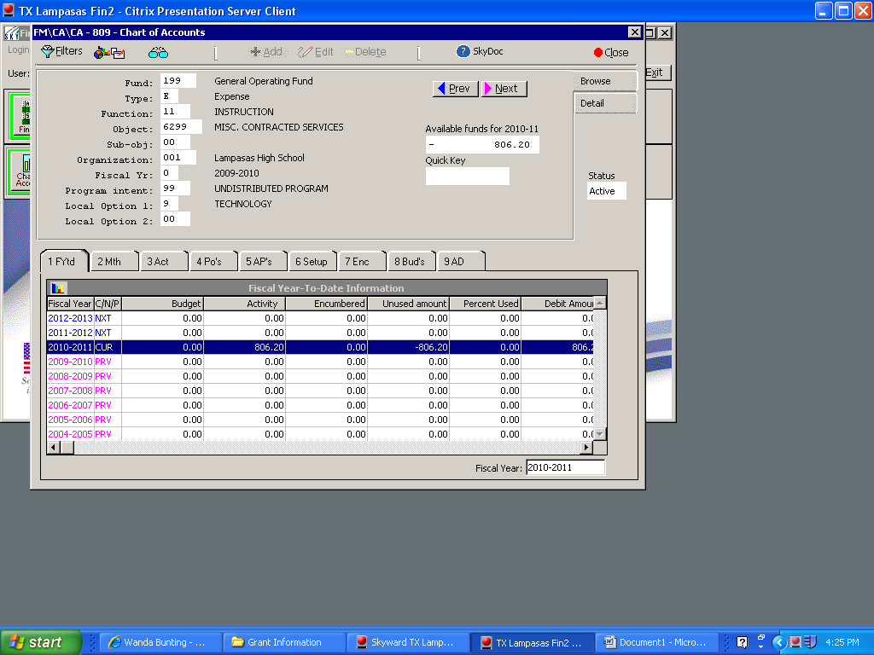

To view the detail on the Act tab, you can drill down further by double clicking on the line that you wish to see or you can click on the View button with the line highlighted.

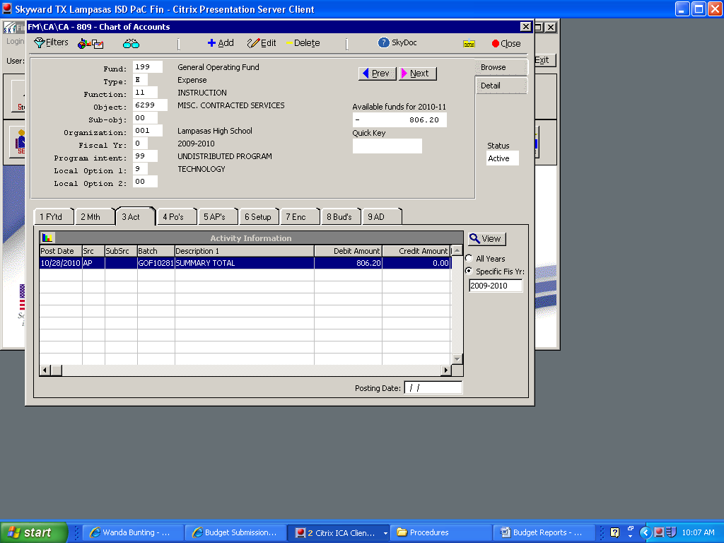

Detail transaction records will display, if you would like further information, you can drill further by double clicking on the line that you wish to see or you can click on the View button with the line highlighted.

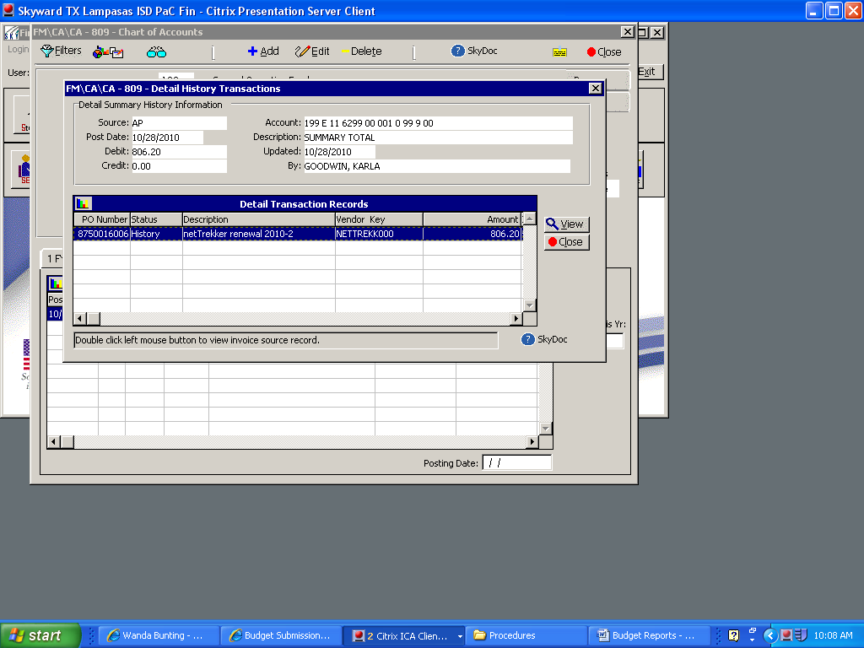

Additional information for the specific expenditure will display as shown below. Click OK to exit.

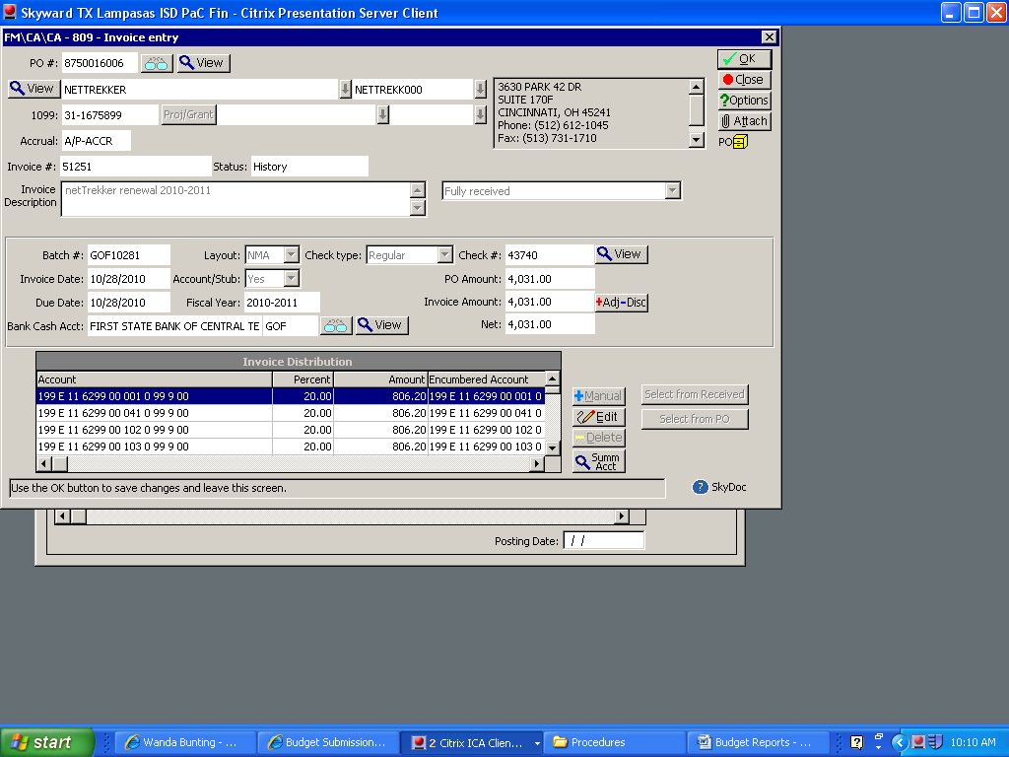

The detail information may help you understand what type of expenditures are charged to this account.

To continue and enter your budget information, click on the Bud’s tab, once you have the budget tab displayed and have selected the correct Fiscal Year, you will click on the **Detail Budget Entry**. (Another option for Budget Data Entry begins on page 24 of this procedure manual.)

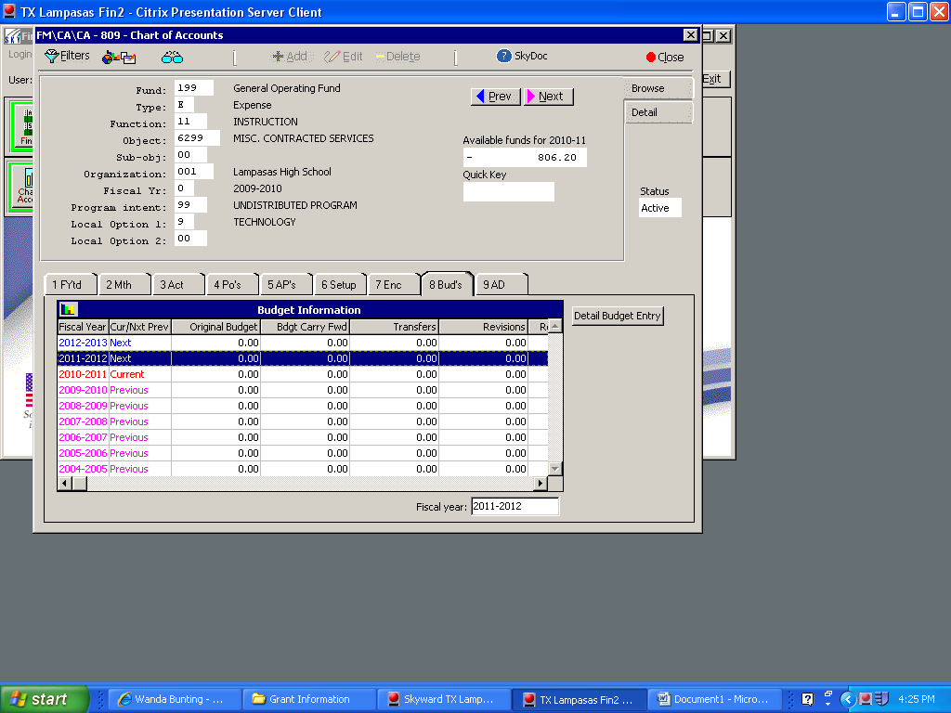

The Detail Budget Entry screen will display and you will select Add to add a detail line item to the budget.

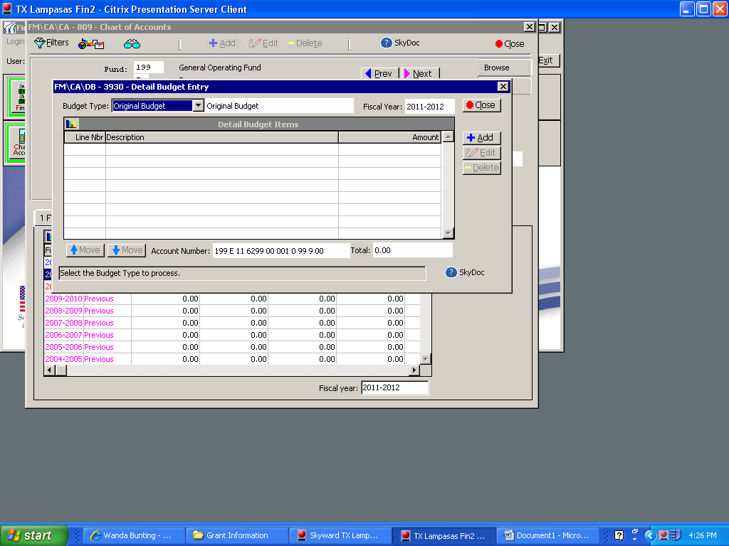

For the detail budget line item you will enter an Item Description and Amount and click OK. Be sure to enter **WHOLE DOLLAR AMOUNTS ONLY**. No cents. *It is recommended that you put your initials at the end of the Item Description so Administration will know who entered the budget detail if there are any questions.*

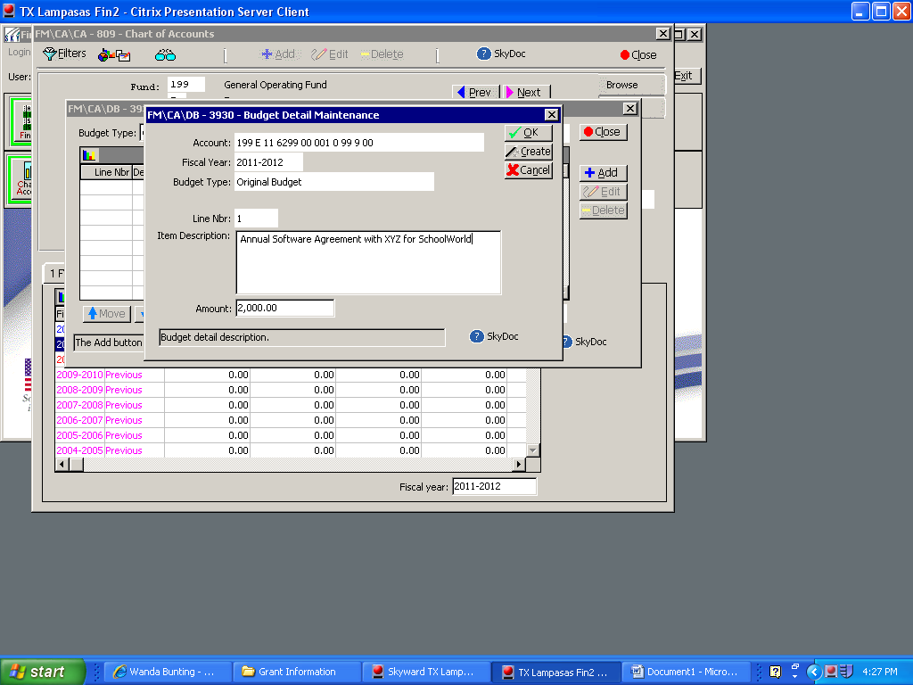

Your detail budget will display and you can add another line item to the budget or you can edit the existing line item. *If the line item carried forward from prior year(s) budget and the item should no longer be in the budget, you can delete the line item.*

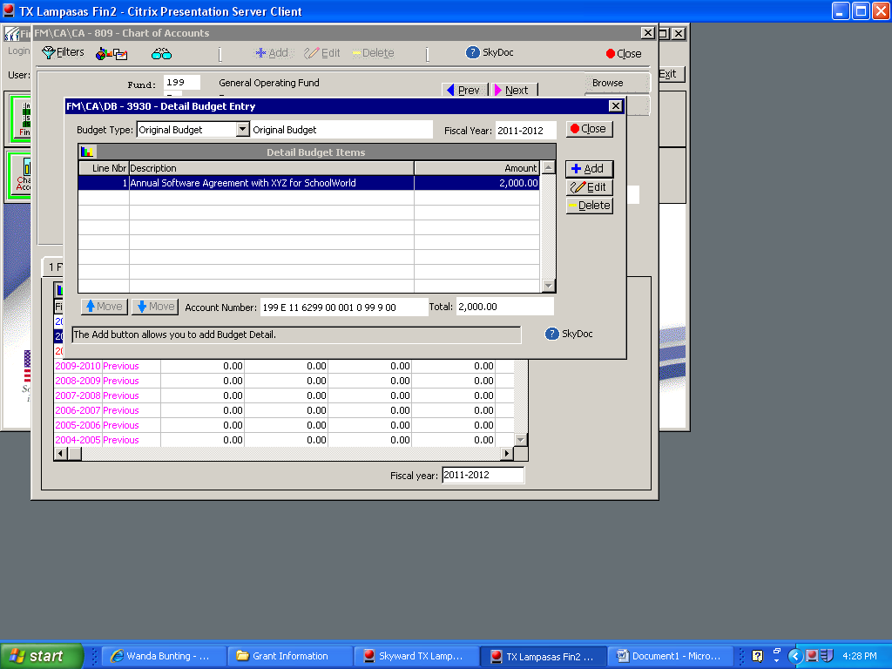

The screen shot below shows adding another line item. Click OK when complete.

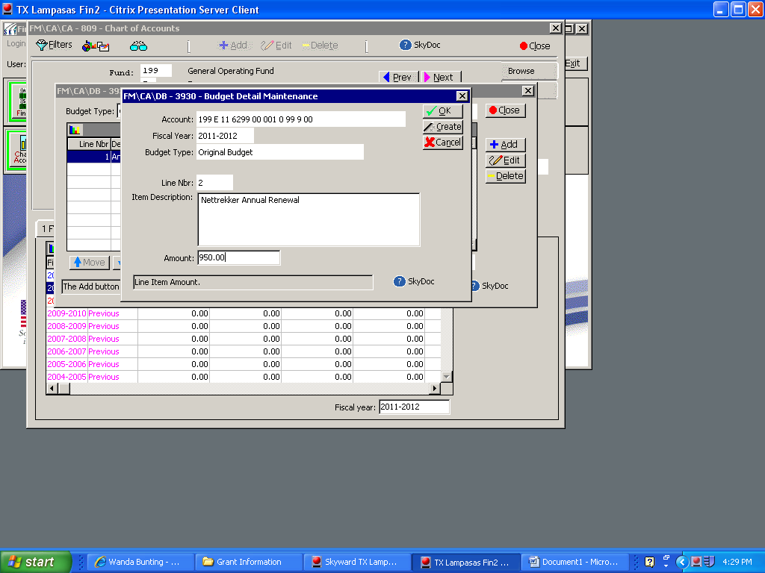

Once you have your detail budget entered for the Account Number selected, click on Close. Clicking on the Close button will save your detail budget entries.

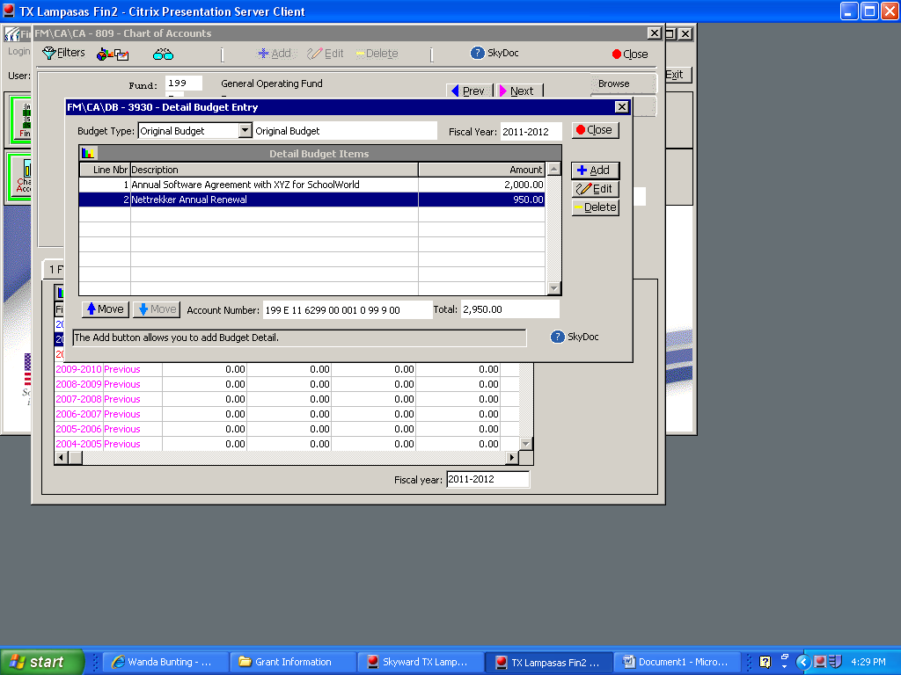

You can continue the process by clicking on the Prev or Next buttons that will take you to other accounts or you can click on the 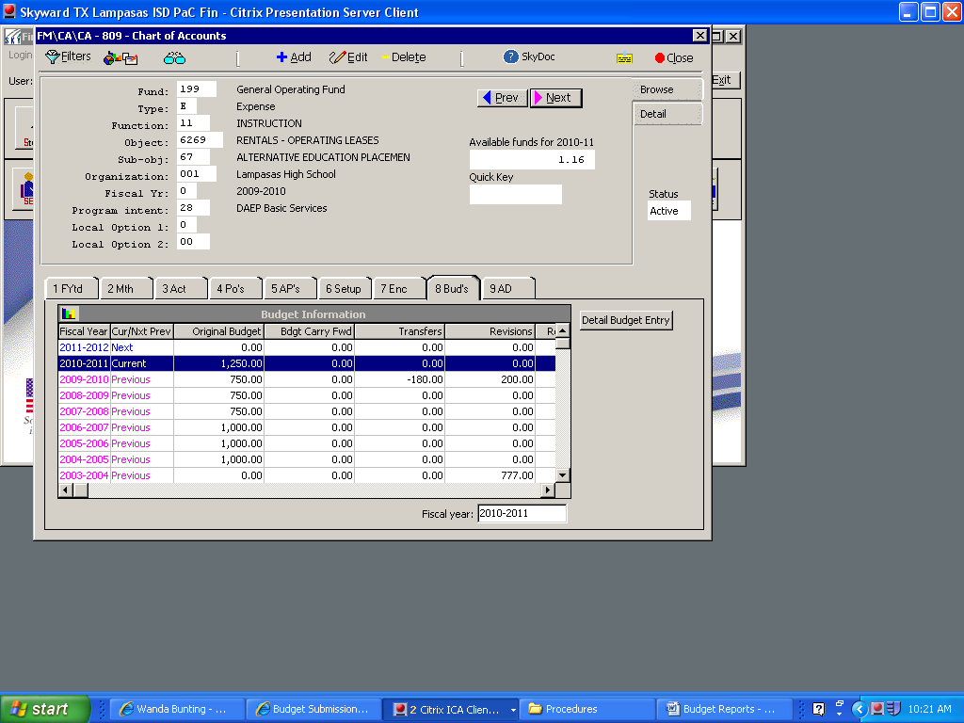 to select another account and repeat the steps above.



**Another Option for Budget Data Entry**

Select the following path: Financial Management > Account Management > Budget Management > Budget Entry.

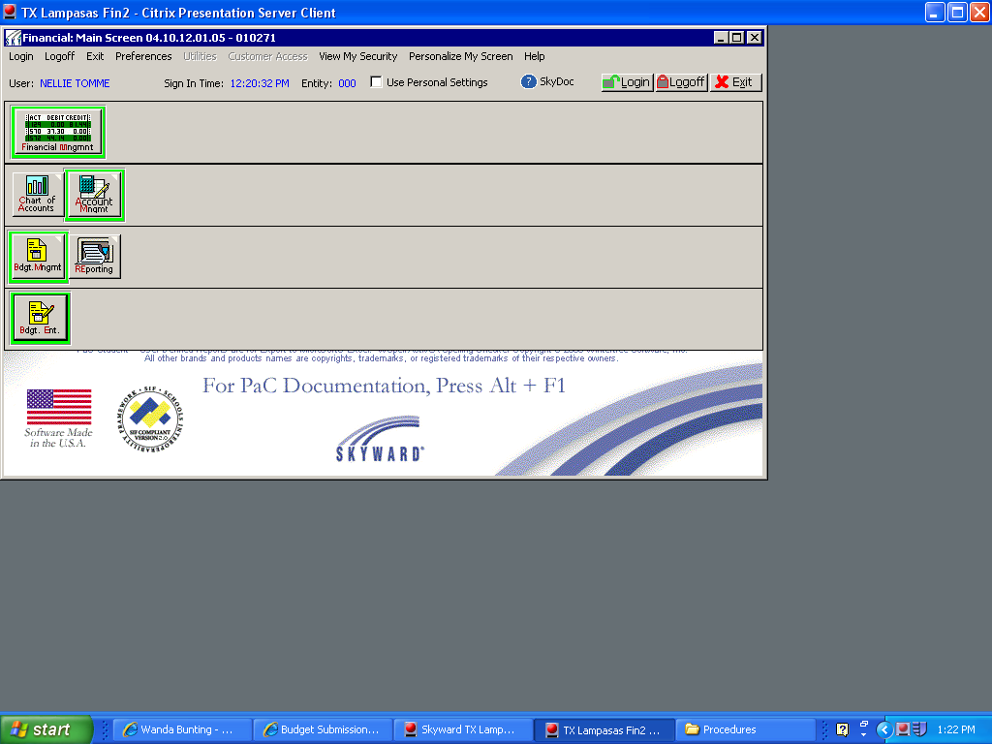

Be sure the Budget Entry 22-23 (**current year**) Budget Process Description is selected. You may need to select View All Budget Processes to see the process below. Be sure that the process is Created By BUNTIWAN000. Click on Process.

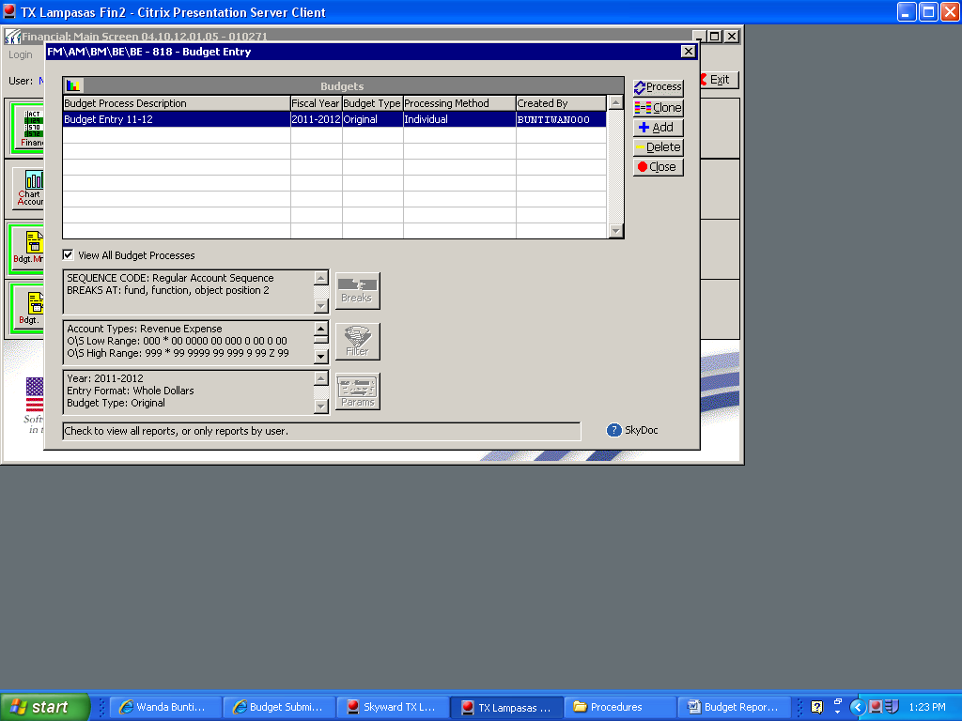

The accounts in which you currently have security in the financial system to view will be displayed. If you need access to any additional accounts or if you have accounts that you are not responsible for, please contact the Director of Accounting to update your Skyward Financial security.

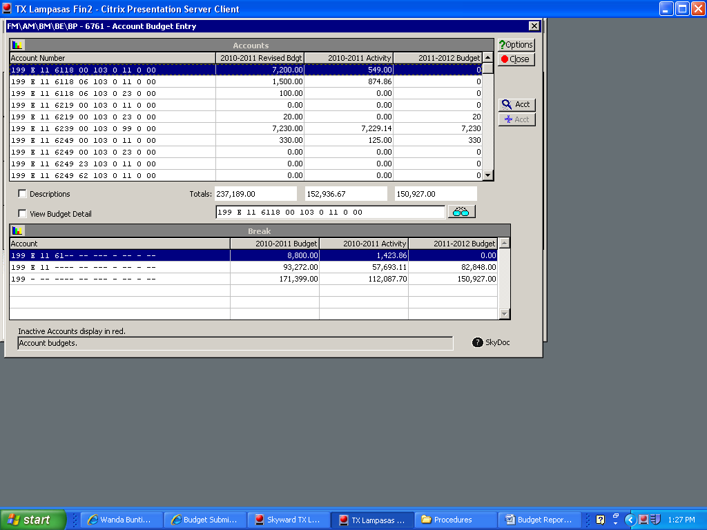

Select the account that you would like to update and be sure to click on the View Budget Detail check box to see the current budget that was rolled forward from the prior year Original Budget. If you click on the Acct button on the right, you will see the detail activity for the account just as you would if you were in the Chart of Accounts (See previous process to enter your budgets.)

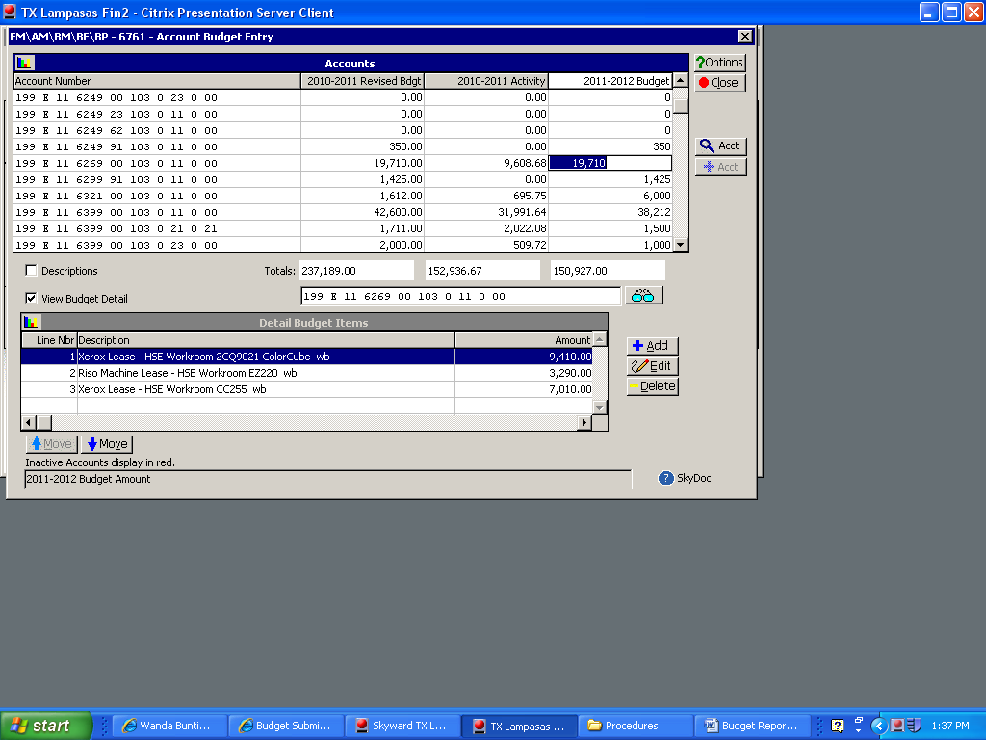

Below is your Chart of Accounts screen where you can view your detail activity. Once you are finished reviewing your detail activity, you may close this window and you will return to the Budget Entry screen.

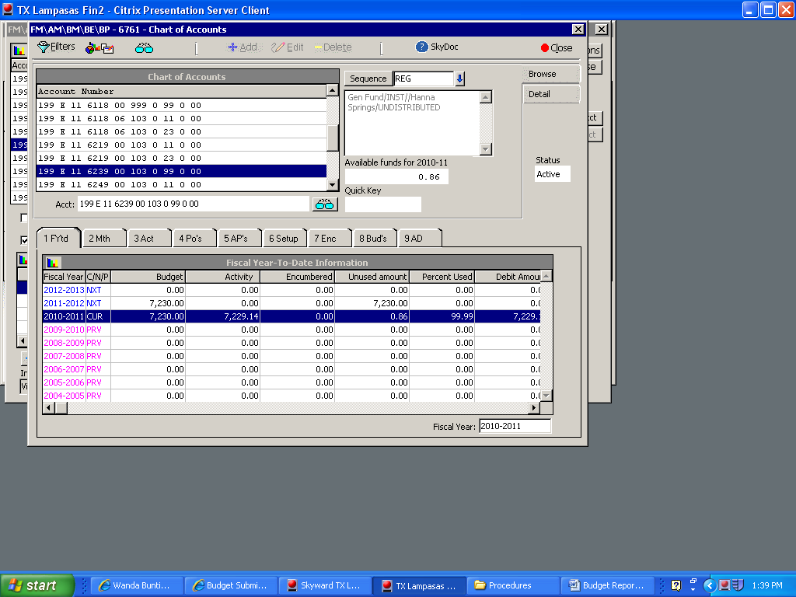

On the budget entry screen, be sure the View Budget Detail box is checked. **All budgets must be entered at the “detail” level.** At the bottom of the screen you will see where you can Add a budget detail line item, Edit the budget detail, or Delete a budget detail line. The detail data entry process works the same as the Chart of Account process previous described in this procedure manual.

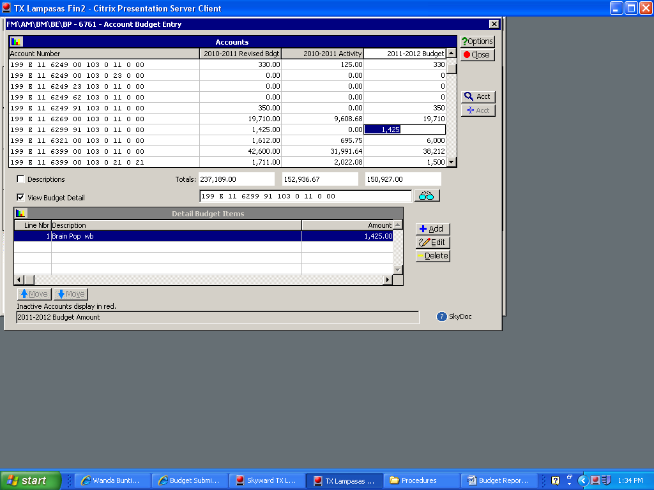

*It is recommended that you put your initials at the end of the Item Description so Administration will know who entered the budget detail if there are any questions.* Once you are finished with your detail budget entry, you will click OK to save the entry and continue through all your detail budget entries by either adding new detail lines or editing existing budget entries.

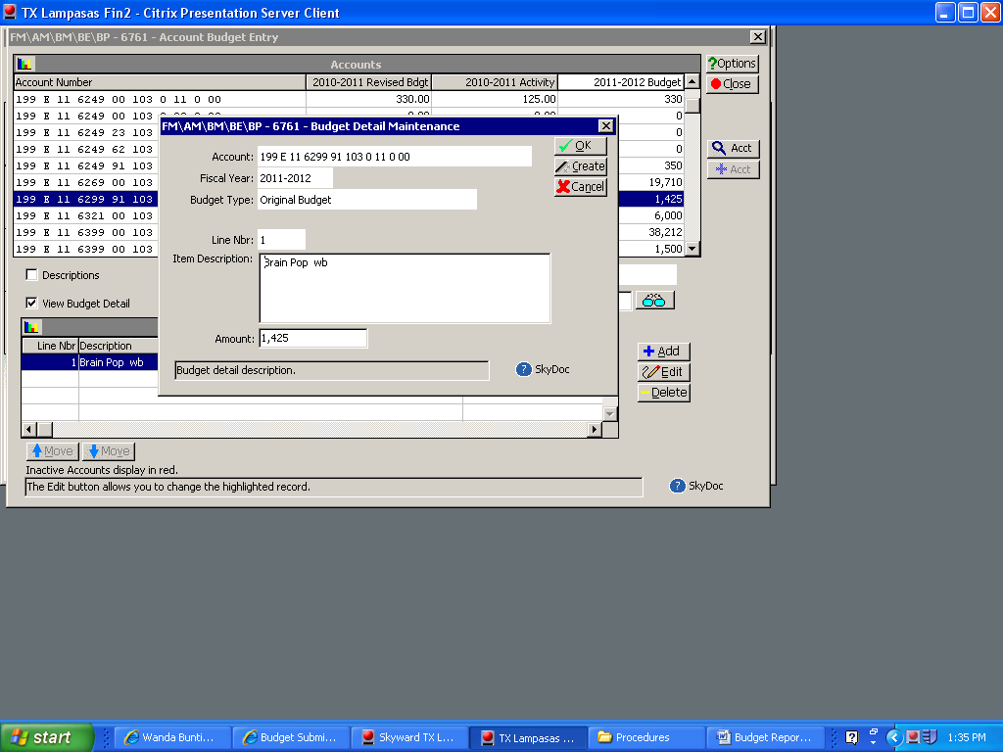

When you finish all your budget entry or you are finished at this point, be sure to click on Close button so that your budget detail will save and update in the financial system.



**Run Summary Reports** --- May be used in your budget planning and/or may be used to review your final budget submission.

Select the following path under Budgetary Data Mining: **Views** (drop down menu) select: Revenue and Expense Reports - Summary. Under **Filters** (drop down menu) select: All Users’ Reports. Then Click on the “**Created By**” title and the system will sort and put all reports created by BUNTIWAN000 toward the top of the list. Once you have the screen below, select the **Rev & Exp Report - Budget Compare** report and click **Print**.

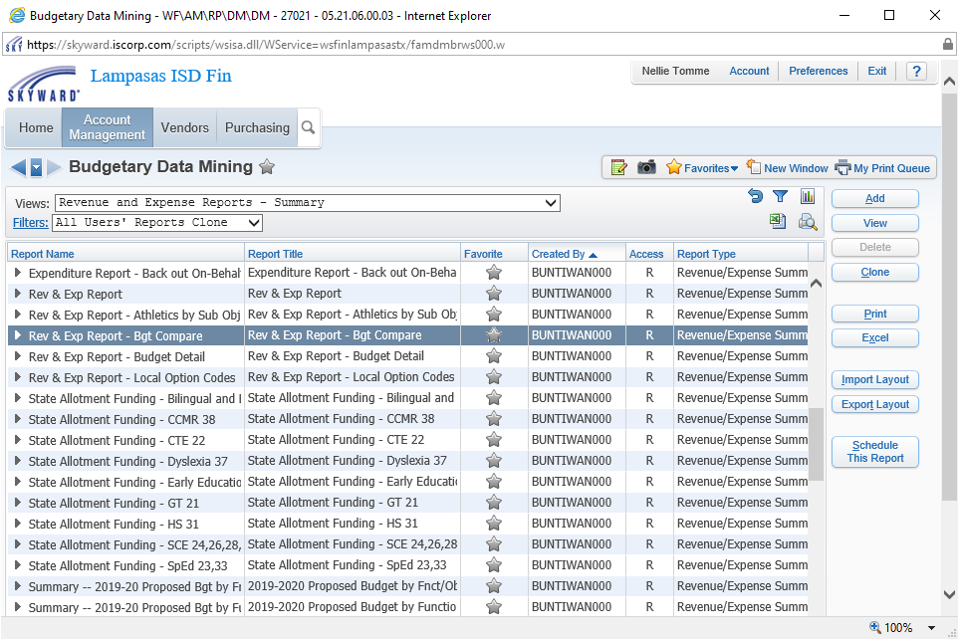

Select the last Reporting Month of the Current Fiscal Year. *So if working on Budget for 2022-23, Select August 2022, click on Print. (****Always select August*** *when running this report so it will include all expenditures for the prior year. If you use April, it will compare expenditures through April of each year.)*

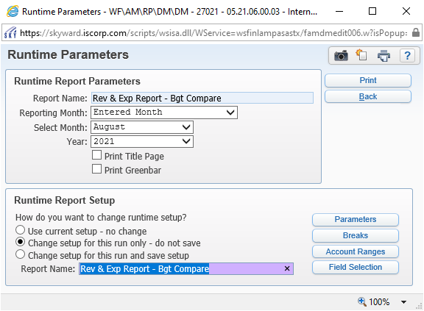

If you run the report using the “Use current setup – no change option”, this will run your entire budget (including salary budget). If you select the “**Change setup for this run only – do not save option**”, then you can update the **Account Ranges**.



Under Operating Statement Accounts update the **Low number for Object to 6200** click **Save**. This will run all non-salary accounts for your campus / department.

After saving you will go back to this screen and you will click **Print**.

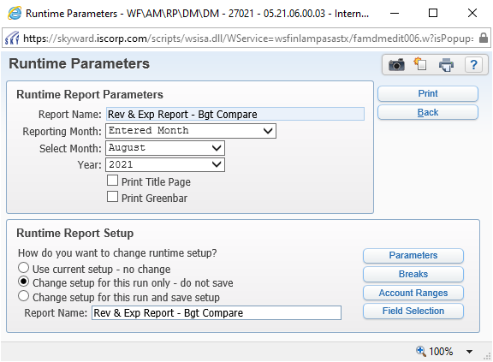

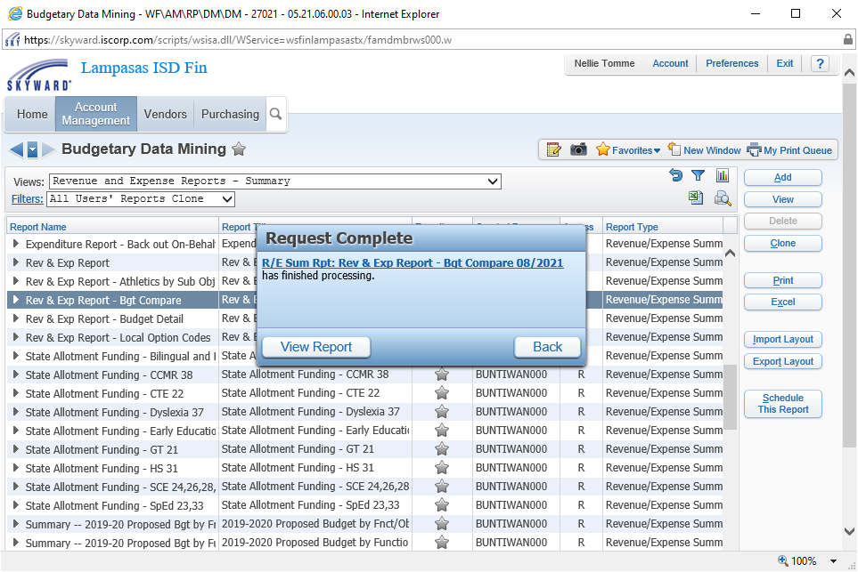

Click **View Report** (above). The report will be displayed. See the following page to see a sample report. If you move your mouse to the bottom center of the report the save and print options will appear. Below is the report that will run, you can save the report to your computer or you can print the report. The report includes all accounts you currently have security to view. If you see accounts that you should not have security for, please contact the Director of Accounting so that the accounts may be assigned to the correct person / department. The report includes history (actual expenditures for prior 2 years) Current Year Original Budget, Current Year Revised Budget, Current year activity (expenditures), and New Year Budget.

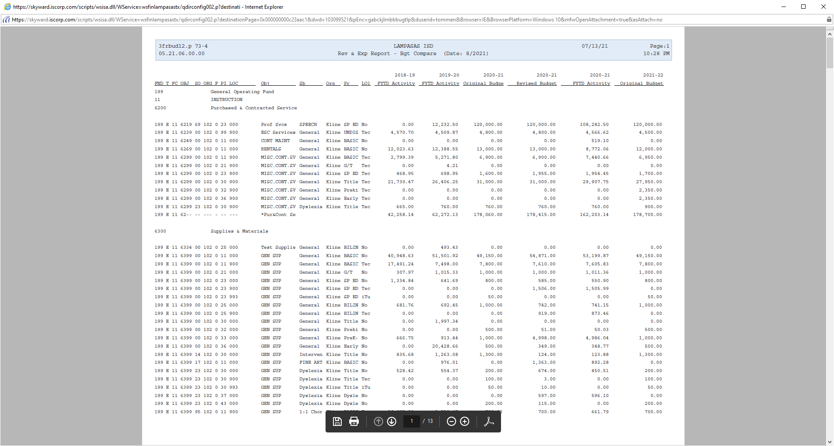

**Budget Detail Report:**

Note: There is also a **Budget Detail report** that will show all line item details entered for your budget. When selecting from the list of reports be sure you have selected the following path under Budgetary Data Mining: **Views** (drop down menu) select: Revenue and Expense Reports - Summary. Under **Filters** (drop down menu) select: All Users’ Reports. Then Click on the “**Created By**” title and the system will sort and put all reports created by BUNTIWAN000 toward the top of the list. Once you have the screen below, select the **Rev & Exp Report – Budget Detail** report and click **Print**.

Select the first Reporting Month of the Budget Fiscal Year. *So if working on Budget for 2022-23, Select* ***September 2022*** *and click on Print.* This report would support all the budget detail that you entered.

