Creating an Extra-Sub in ReadySub

(Extra substitute will not be subbing for someone)

*Follow these procedures to ensure that “Limited” Substitutes are NOT used as Extra Subs or in Vacant Positions.*

Select **Post Job** under the Jobs section.

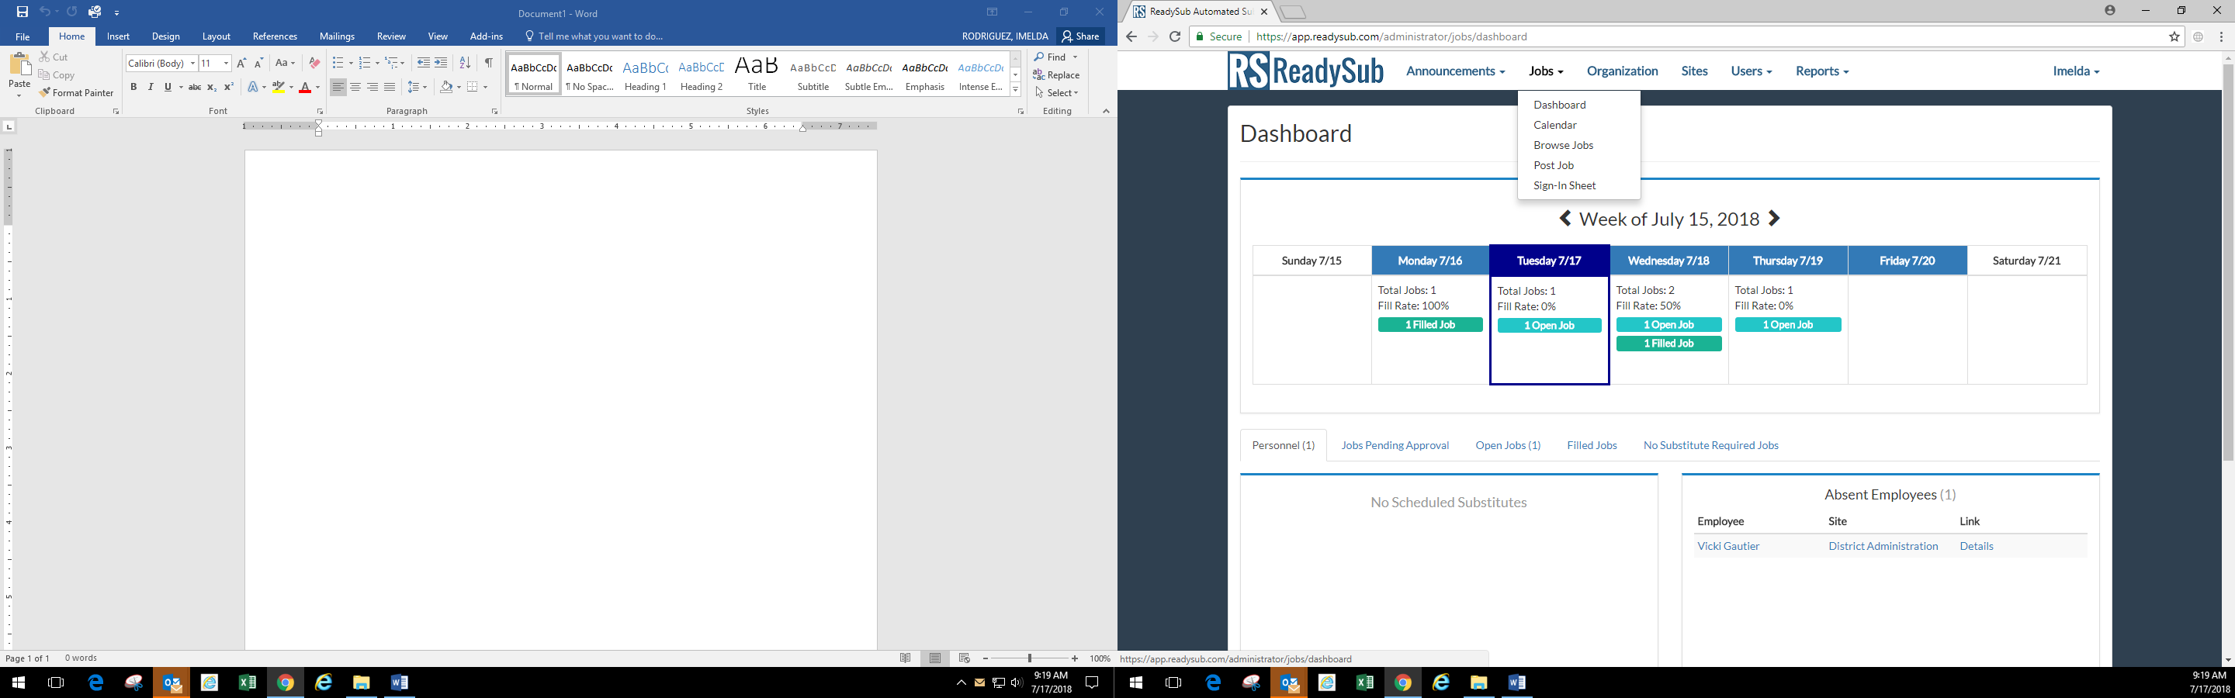

Select the following:

* **Vacancy** under the Employee section
* **Extra Sub** under the Job Classification
* **Extra Sub** under the Job Reason
* Click Next

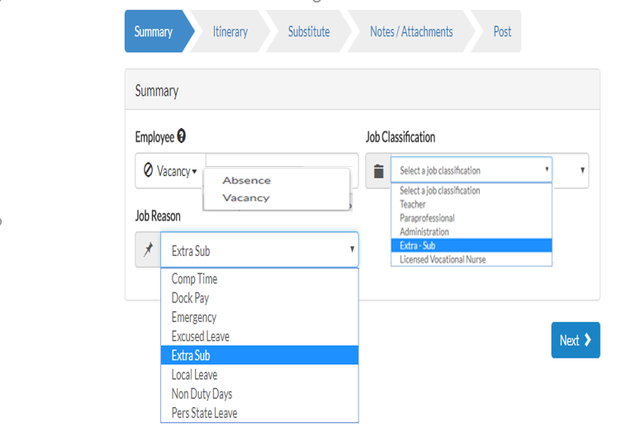

Select **Single Day or a Multi Day** and enter the date(s). If Multi Day is selected, each day will need to be selected individualy.

Click **Add Segment**.

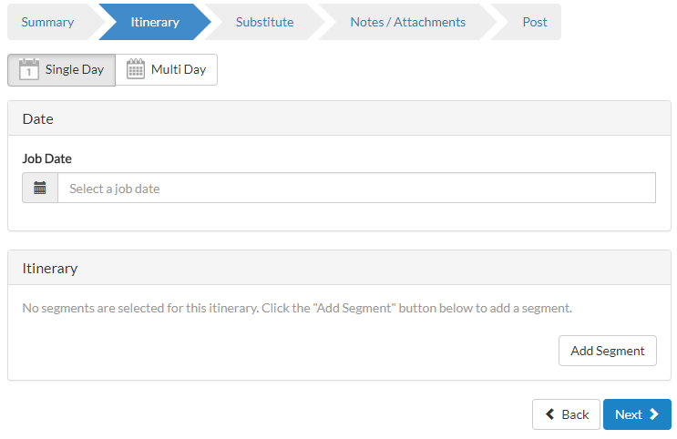

**Select the campus**. (Campus level employees should only be able to assign to their campus.)

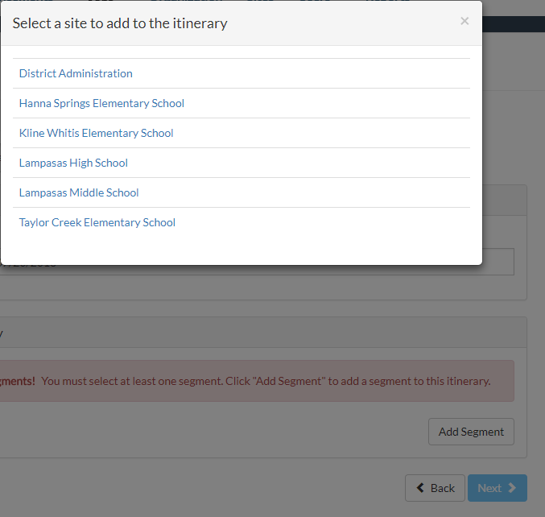

Select the **Schedule.** It can be a Full Day, Half Day AM or Half Day PM.

Under the Job Position, make sure a **Paraprofessional Extra** or **Teacher Extra** is selected since this is an optional field.

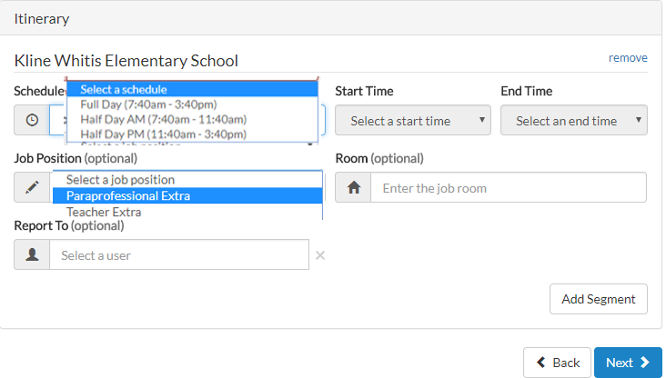

**Notes or attachments** can be added in this section. Click next.

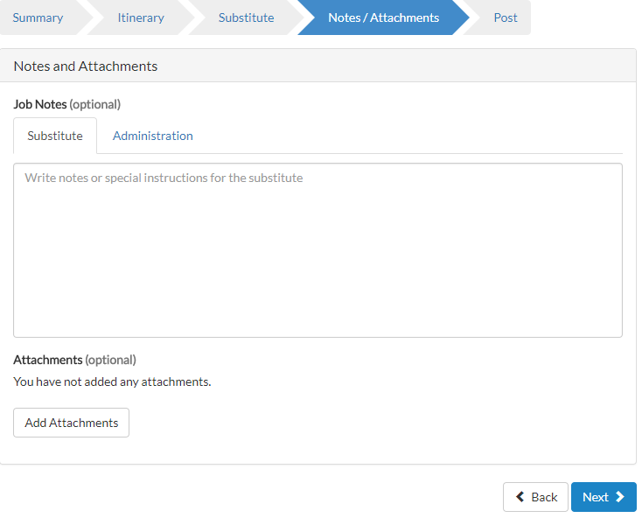

At this point you can select to **post to pool, request a substitute or assign a substitute**. Click Next.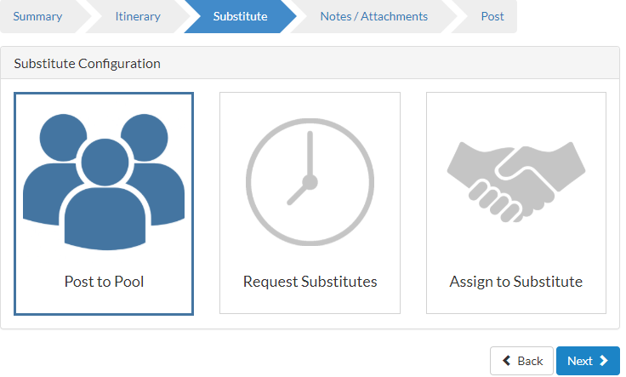

If you select Request Substitutes or Assign to Substitute, you will not be able to select or assign the job to a ***Not Qualified*** (*Limited*) Sub. *No Limited Sub should ever fill a “Vacancy / Extra Sub” positon. Limited substitutes must always sub for a current employee.*

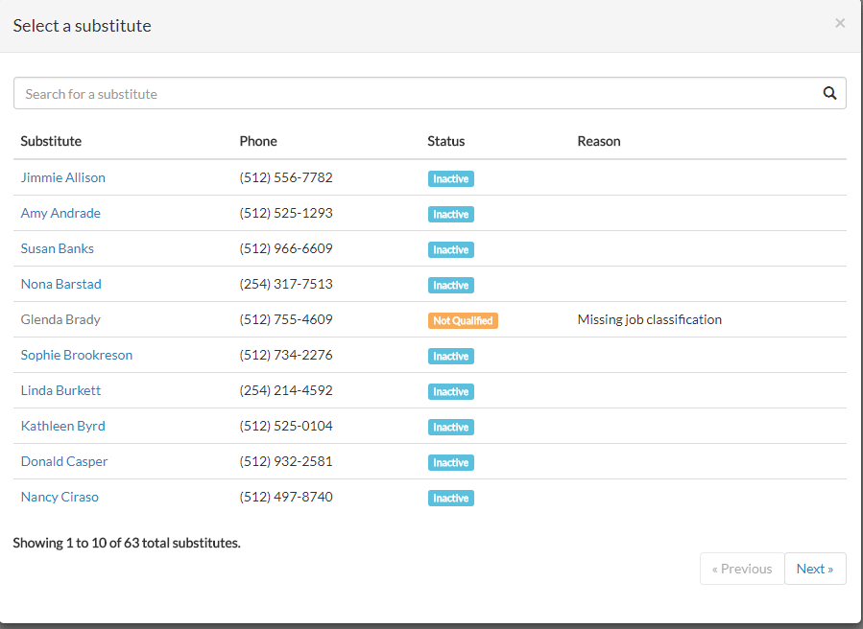

Review the summary and **post job.**

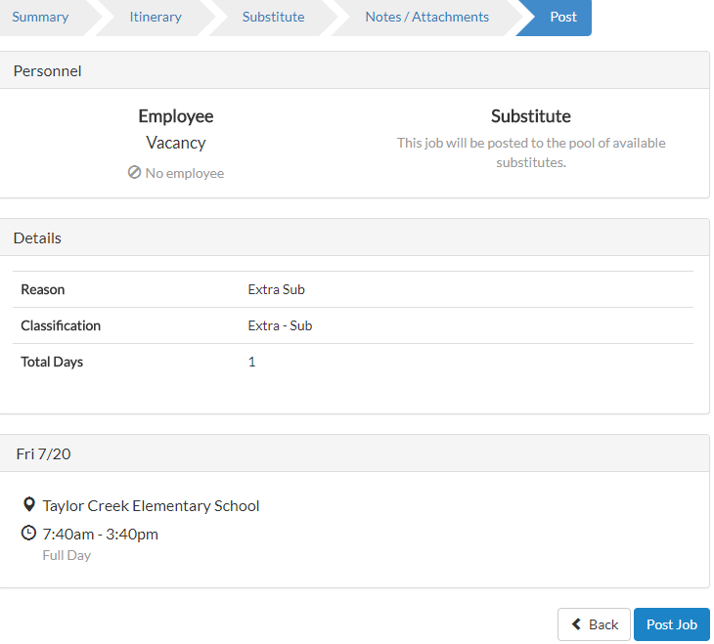

***Note: The only time you should be assigning a substitute is when you have already contacted the sub and know that they have accepted the position. If time allows, it is recommended that you always “Post to Pool.”***

***Only Administrators have security to “Assign a Substitute”.***