**Budget Transfer Procedures – Automated in Skyward**

Start by setting up your notifications under ***Financial Management > Account Management > Budget Management > Transfers > Setup > Configuration***

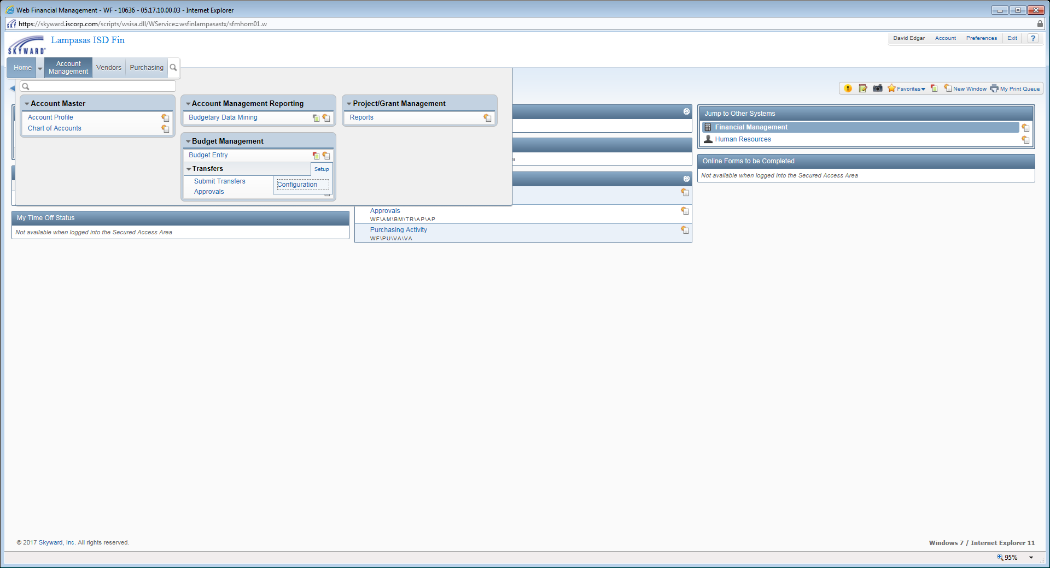

Select ***Budget Transfer Notification Options***

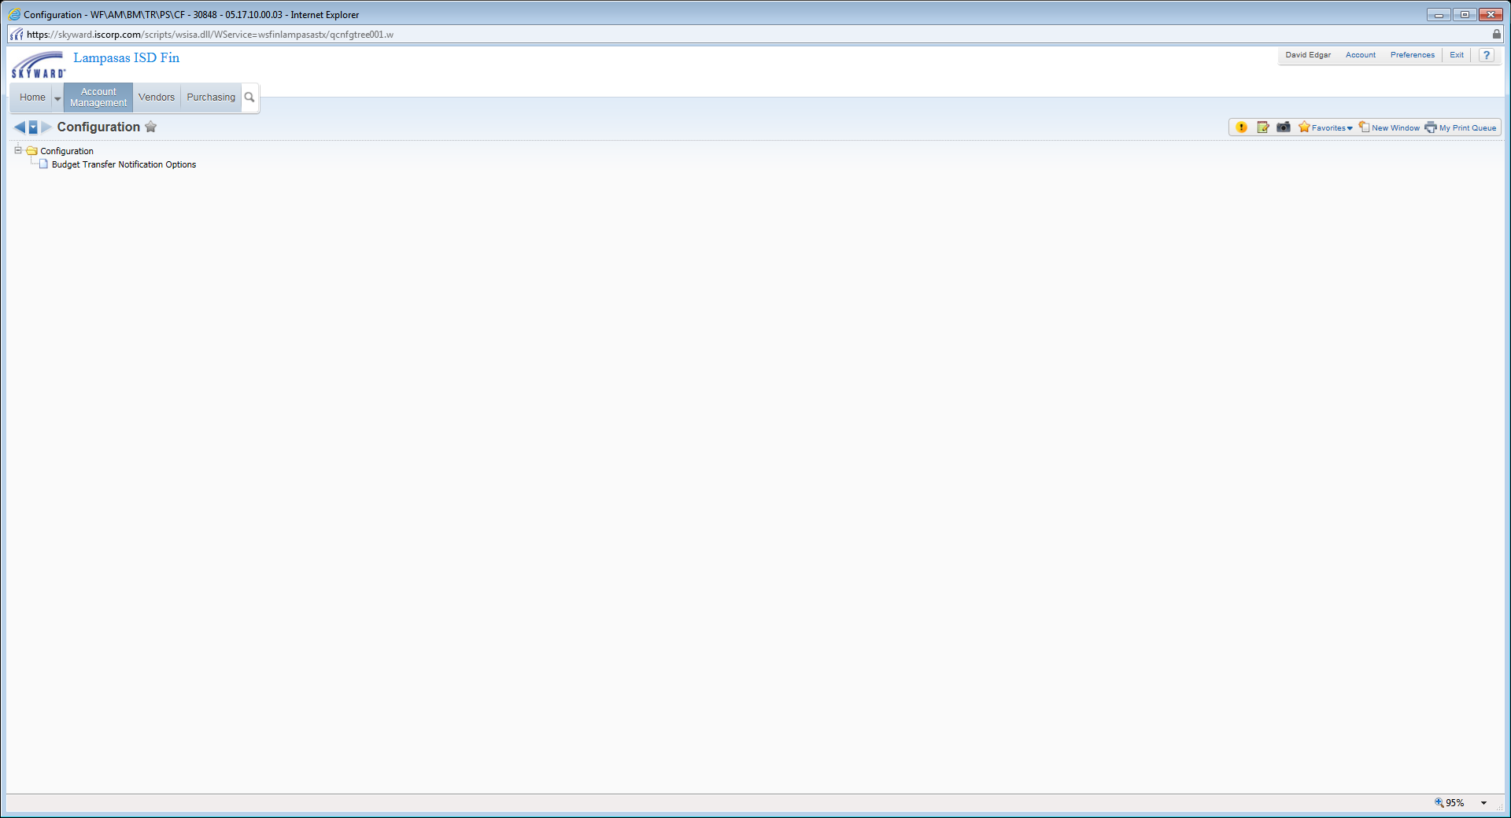

**Staff Entering Request:** Select when you would like to receive an email notification (after approved, etc.) - ***Save***

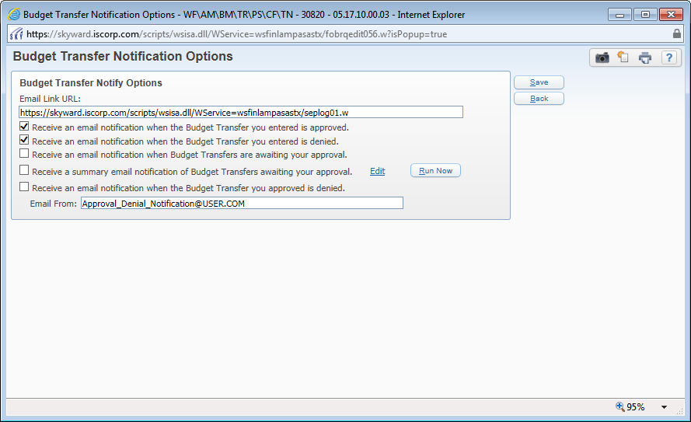

**Approvers:** Select when you would like to receive an email notification (awaiting your approval, etc.) - ***Save***

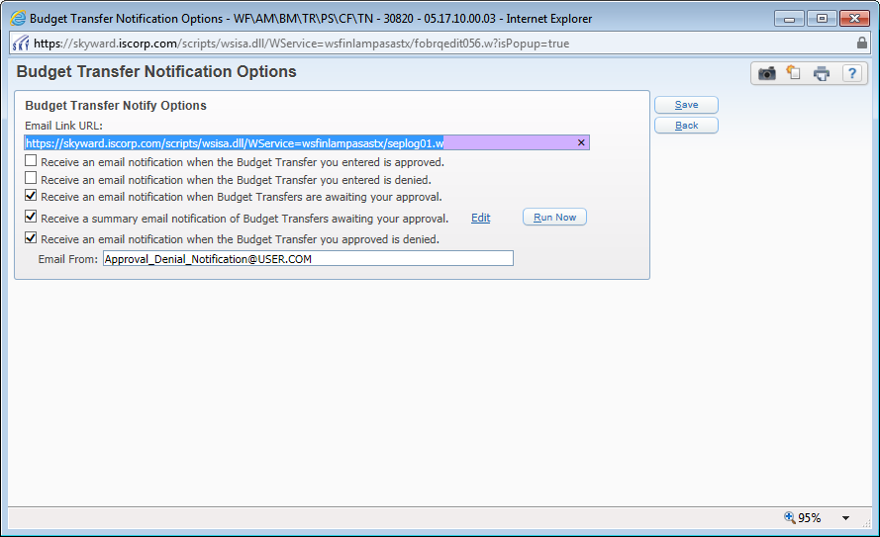

Run your campus / department Budget Report *(see Budget Procedures for instructions on running a report)* and review your Budget status. If you have a negative Unencumbered Balance or if you have a requisition that you plan to enter soon that will cause an account to be negative, determine if you have available funds in another account.

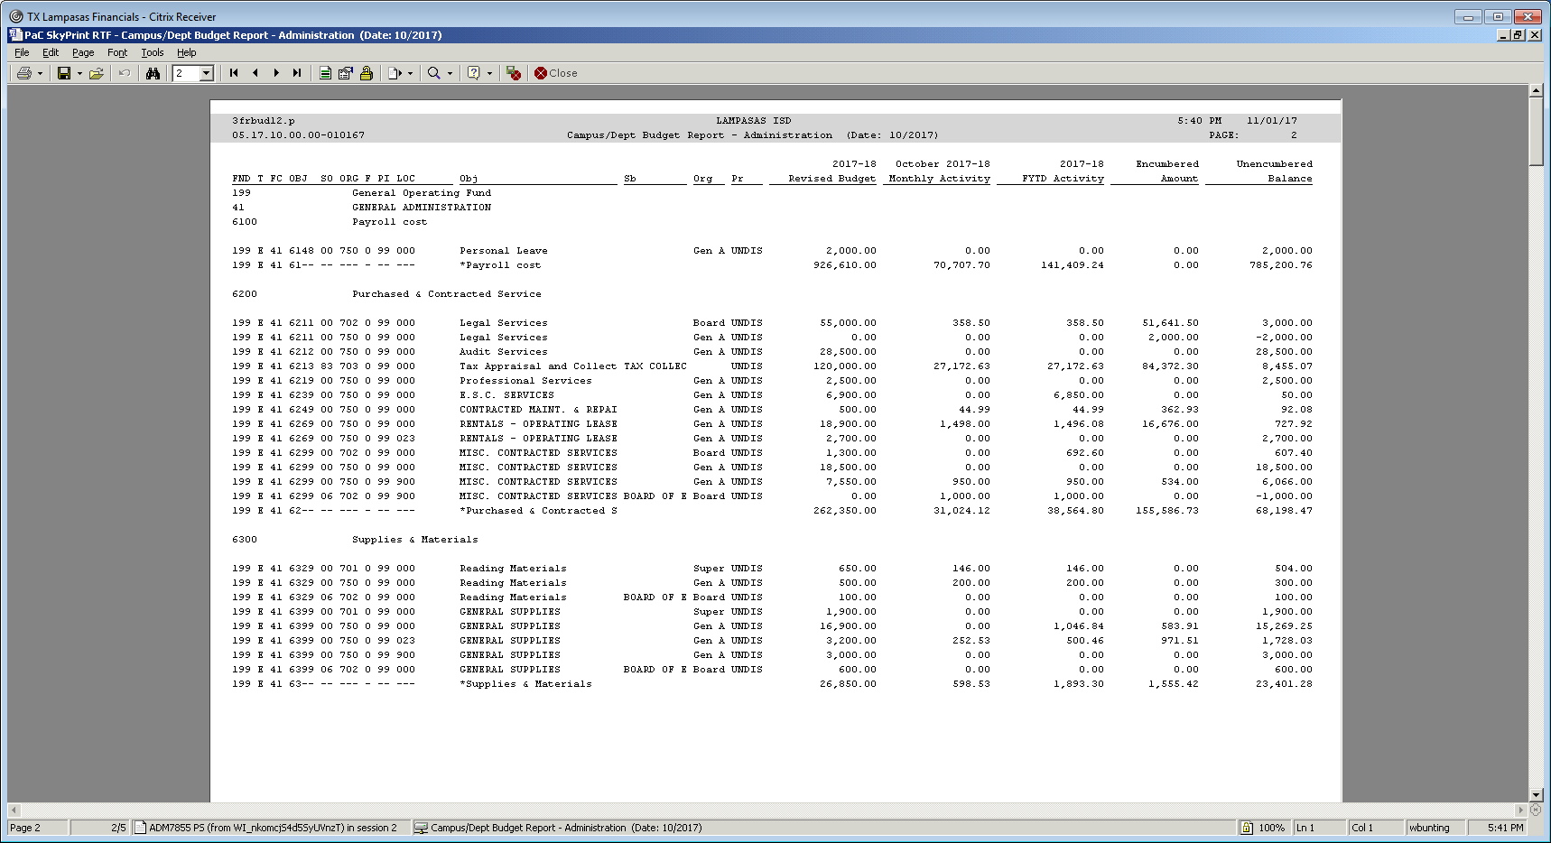

To submit a Budget Transfer, go to ***Financial Management > Account Management > Budget Management > Transfers > Submit Transfers***  *(Only Funds 199 & 2XX have budgets) There is no budget for activity accounts.*



Enter the Budget Transfer Group (most of you will only have one group available); make sure the correct Fiscal Year is selected; enter a Description. Then under the Detail Budget Transfer section, enter the account number that you plan to decrease (transfer from) and the transfer amount, and a description. Repeat with all of your account transfers. *Transfer From is Decreasing the Budget*. *Transfer To is Increasing the Budget*. - ***Submit for Approval***

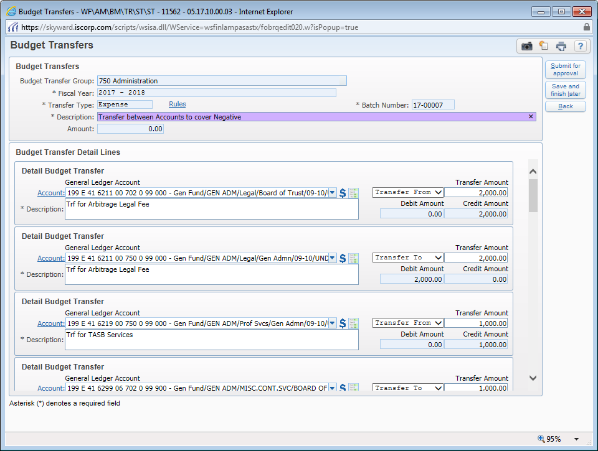

If you get the message below, click **Cancel**, go back and figure out what account has funds available. Do not click ok to allow an account that does not have funds available. This will just be creating another negative balance. Review your current remaining balance (Unencumbered Balance) to determine accounts that currently have funds available. You may want to review the budget detail to determine if you will need these funds later in the year.

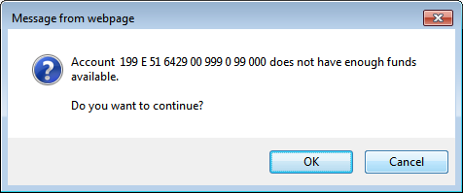

Once you submit for approval, the ***approver should receive an email similar to the one below***. (Current approvers: Purchasing Coordinator will review to make sure all accounts look ok, after her review, the budget transfer will go to the principal/director for review/approval, once they have approved, then the budget transfer will go to the Director of Accounting for final approval/posting.)

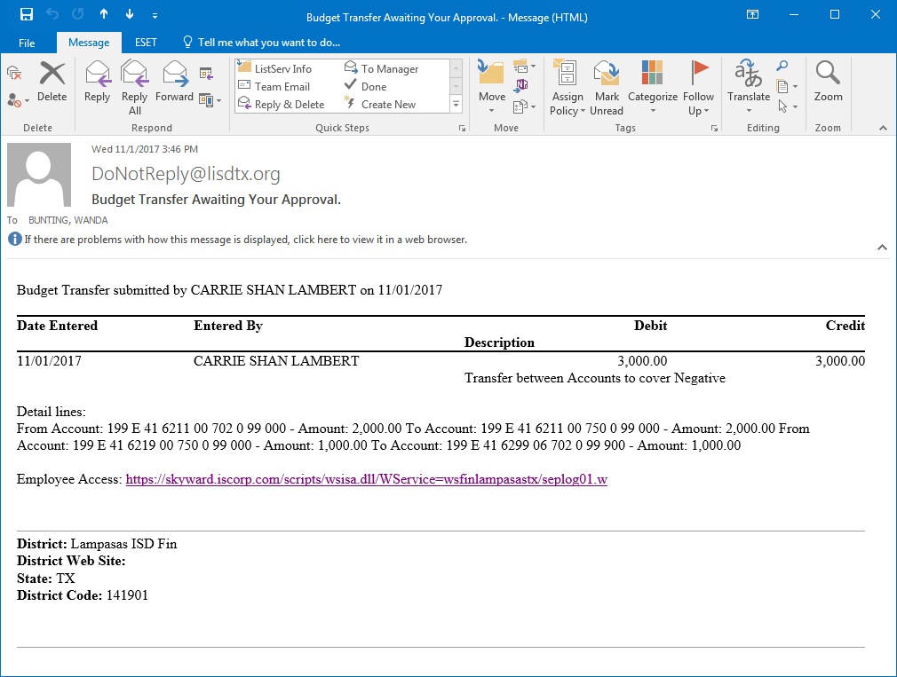

To approve, go to ***Financial Management > Account Management > Budget Management > Transfers > Approvals***



To review the budget transfer, you can click on the arrow on the left and then click on ***Expand All*** to see the detail prior to you ***clicking on Approve and Submit Approval and Denials*** -- After the Director of Accounting posts the entry, the funds will be available in your account. *If the transfer crosses functions, the School Board will have to approve prior to the Director of Accounting posting the entry. (example: 199-****11****-6399… to 199-****23****-6399…) Budget transfers must be between accounts within the SAME fund.*

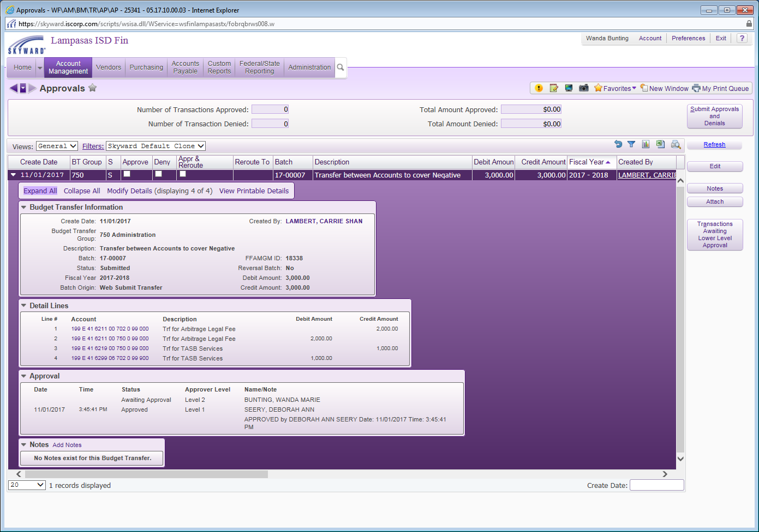

After clicking on the “Submit Approvals and Denials”, you will get a confirmation – click ***Yes***

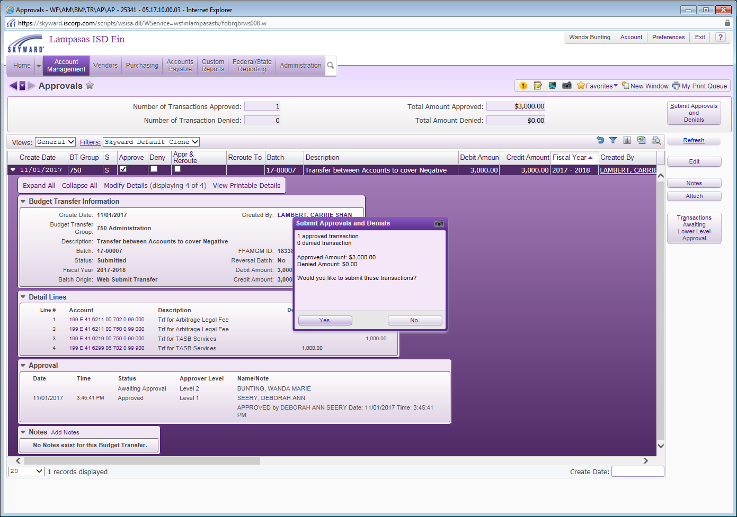

***When the Budget Transfer is Approved***, the submitter should receive an email like the one below.

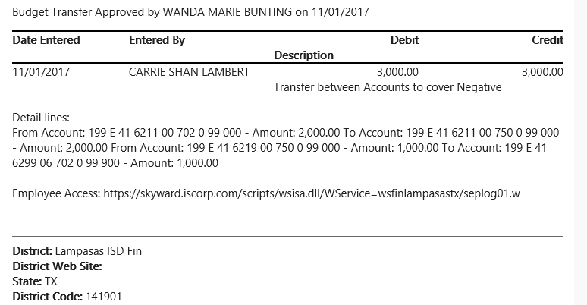

***After the budget transfer is posted to the individual accounts***, the submitter should receive an email like the one below showing that the entry has been posted.

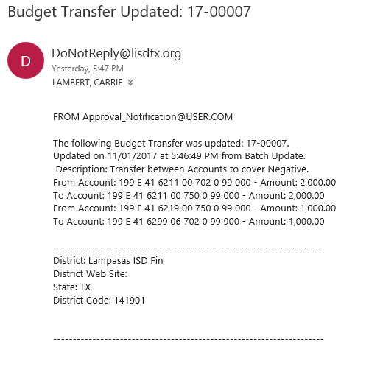

***After posting, the accounts will no longer have negative balances.***

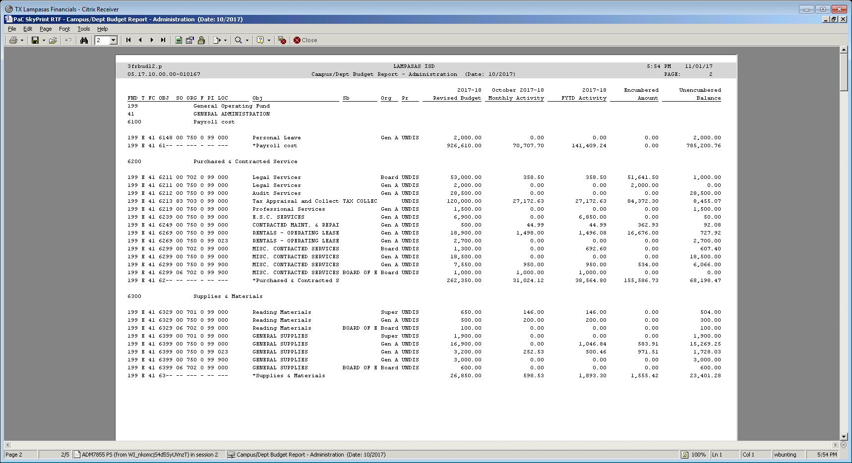

For ***Donations and Transfers from Activity Accounts***, follow the same process above to increase the accounts. These transfers must be processed by mid July to allow enough time to get on the August School Board agenda for approval in August.

As a reminder, the *Activity Accounts (Fund 461, 865, and 878) do NOT have budgets*, so you will never have a budget transfer in these funds.

For Donations (see example below):

* Always use 199 E 00 6044 00 000 0 00 000 as the account that you “Transfer From”
  + *(Account 6044 will be combined into 199-00-5744 at fiscal year end by business office)*
* Enter the account number where you would like to spend the donated funds. (Remember that you must spend the funds in the fiscal year that you receive the donation.)
* In the description, be sure to enter where the donation is from and how you plan to use the funds.

For Transfers from Activity Accounts:

* Always use 199 E 00 6049 00 000 0 00 000 as the account that you “Transfer From”
  + *(Account 6049 will be combined into 199-00-5749 at fiscal year end by business office)*
* Enter the account number where you would like to spend the funds that were transferred from the activity account. (Remember that you must spend the funds in the same fiscal year that you transfer the funds from your activity account.)
* Be sure to enter where the funds are from and what you plan to use the funds for in the description.
  + (example: Cross country activity transfer to purchase stop watches)

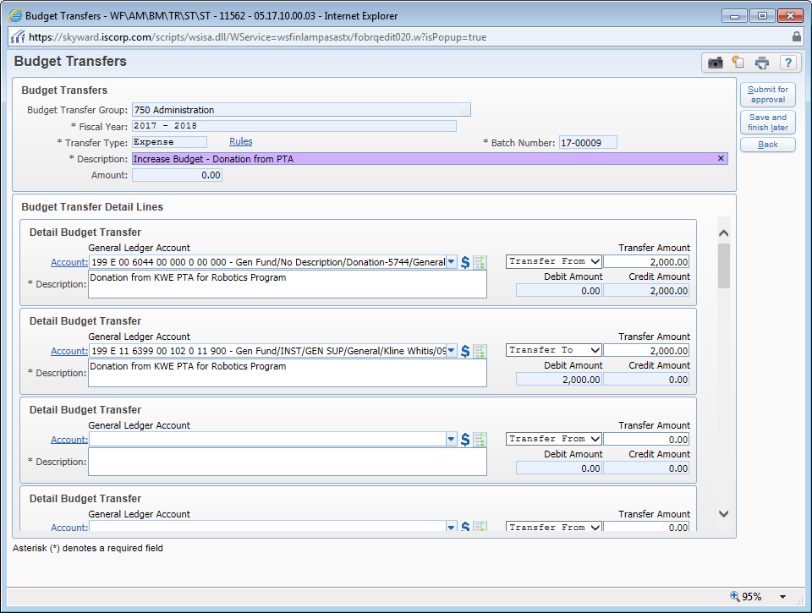

You will get this message when you enter these accounts (199 E 00 6044 - Donation account or the 199 E 00 6049 - Miscellaneous Revenue account) on a Budget Transfer since they are just place holder accounts that will be used throughout the year until the business office moves the budget from these accounts to the corresponding revenue accounts 199 R 00 5744 and 199 R 00 5749 at year end. – *Click* ***OK*** *when you receive this message for these two accounts ONLY.*

