**TIPS on Preparing your Files for Storage**

1. **Do not tape** the box shut.

2. **Do not overstuff**! The boxes are too heavy to handle and lose shape.

3. **Tape the white copy** of the transmittal form to the END of the box as indicated

in the picture below. Don’t put the label on the lid!

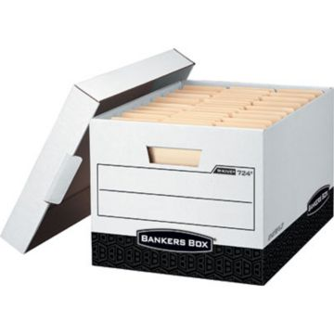

Tape the transmittal form and the label with the box number here

4. **Include the school year** with a brief description of the contents on the transmittal form.

5. Be sure to **include sender’s name** so if there’s a question, we know who to call.

6. Affix the assigned label to the lower right hand corner of the box and be sure to write the same number on the transmittal record form.

7. Put the yellow copy inside the box. Sender keeps the goldenrod copy.

SEND THE PINK COPY OF THE TRANSMITTAL FORM TO TAYLOR WOOD FOR INVENTORY PURPOSES